Using Standard Units to Estimate, Measure, and Compare Area
Uses non-standard units to measure  “Its area is 8 Colour Tiles.” | Uses standard-sized items to measure  “Its area is 50 square centimetres.” | Uses partial units to get more precise measure  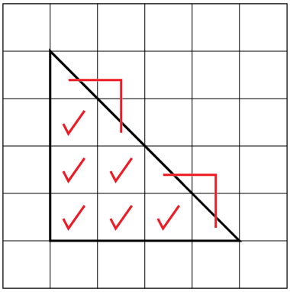  “6 whole squares and  4 half squares.  Area is 8 square centimetres.” | Measures using multiple copies of a unit  “I skip-counted by 10 five times:  10, 20, 30, 40, 50.  Area is 50 square centimetres.”
Observations/Documentation

Using Standard Units to Estimate, Measure, and Compare Area (con’t)
Measures using intermediary shape (e.g., shape whose area is known)  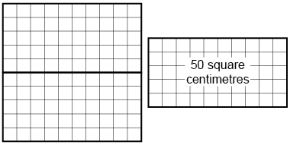  “Each rectangle has area 50 square centimetres, so the area of the square is 100 square centimetres.” | Uses benchmarks to estimate in standard units  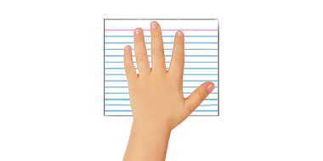  “Area of hand: about 100 square centimetres. The card is a bit bigger, so I estimate 125 square centimetres.” | Selects and uses appropriate standard units  “I would use square metres to measure the area of the floor because it is much bigger than a square made from metre sticks.” | Compares using standard units  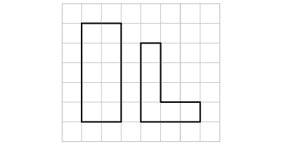  “The rectangle:  10 square centimetres is bigger than 6 square centimetres.”

Using Standard Units to Estimate and Measure Mass and Capacity
Uses non-standard units to measure  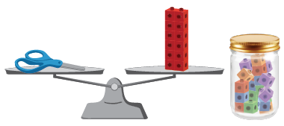  “The scissors have a mass of  about 12 linking cubes.  The jar has a capacity of  about 20 linking cubes.” | Uses multiple copies of standard-sized items to measure  “I added 1-g masses to the pan until the pans balanced. The eraser has a mass of 20 g.  I filled the 100-mL cylinder and poured it  into the jug. I did this 6 times.  The capacity of the jug is 600 mL.” | Measures using intermediary object (e.g., object whose mass/capacity is known)  “I know the soup can has a mass of about 300 g, so I started with that and added other masses.  I used the water bottle to fill the bowl. It didn’t quite fill it, so I then used the 100-mL cylinder.”
Observations/Documentation

Using Standard Units to Estimate and Measure Mass and Capacity (con’t)
Uses benchmarks to estimate in standard units  “My pencil case is a bit heavier than a can of tuna, so I estimate 225 g.  The bottle is a bit smaller than a carton of milk, so I estimate 900 mL.” | Selects and uses appropriate standard units  “It’s lighter than a box of salt,  so I will use grams.  It’s bigger than a milk carton,  so I will use litres.” | Compares using standard units  “1 L is more than 750 mL, so the milk carton holds more than the yogurt tub.”
Observations/Documentation

