Using Standard Units to Estimate, Measure, and Compare Area
Uses non-standard units to measure  “Its area is 8 Colour Tiles.” | Uses standard-sized items to measure  “Its area is 50 square centimetres.” | Uses partial units to get more precise measure  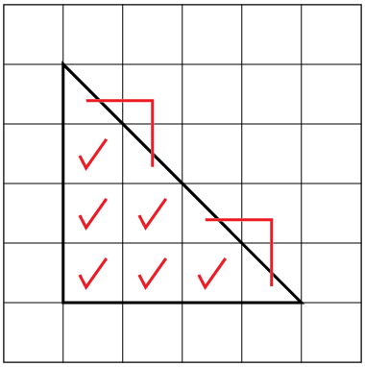  “6 whole squares and  4 half squares.  Area is 8 square centimetres.” | Measures using multiple copies of a unit  “I skip-counted by 10 five times:  10, 20, 30, 40, 50.  Area is 50 square centimetres.”
Observations/Documentation

Using Standard Units to Estimate, Measure, and Compare Area (con’t)
Measures using intermediary shape (e.g., shape whose area is known)  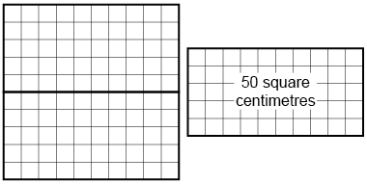  “Each rectangle has area 50 square centimetres, so the area of the square is 100 square centimetres.” | Uses benchmarks to estimate in standard units  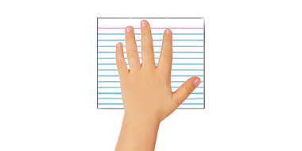  “Area of hand: about 100 square centimetres. The card is a bit bigger, so I estimate 125 square centimetres.” | Selects and uses appropriate standard units  “I would use square metres to measure the area of the floor because it is much bigger than a square made from metre sticks.” | Compares using standard units  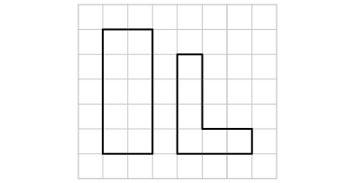  “The rectangle:  10 square centimetres is bigger than 6 square centimetres.”

Relationships in Area, Mass, and Capacity
Measures using different non-standard units for area, mass, and capacity  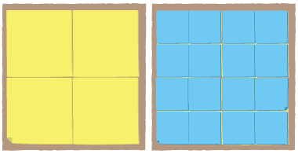  “I covered the shape with big squares, then with small squares.” | Uses the relationship between non-standard units to explain measures  “The bigger the cube, the fewer I needed to fill the milk carton.  The smaller the square, the more I needed to cover the shape.” | Uses conservation of area and mass to predict measures  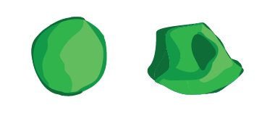  “I reshaped the modelling clay and its mass didn’t change. It was 375 g both times.” | Flexibly uses the relationships among measurement units  “375 g is less than 1 kg  because 1 kg is 1000 g.”
Observations/Documentation

