Comparing Angles
Identifies number of vertices as a geometric attribute of a shape  “A square has 4 vertices.” | Relates vertices of shapes to angles  “A square has 4 vertices, so it has 4 angles.” | Identifies right angles using manipulatives  “This is a right angle because it is the same  as the corner of a square.”
Observations/Documentation

Comparing Angles (con’t)
Uses right angle as benchmark for comparison  “This triangle has angles less than a right angle. The angle is greater than a right angle.” | Sorts shapes using attributes related to angles  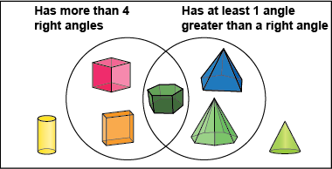  “The solid in the overlap has more than 4 right angles and at least one angle greater  than a right angle.” | Flexibly compares angles  “I pictured putting a square in the angle and there was space left over. It’s bigger than a right angle.”  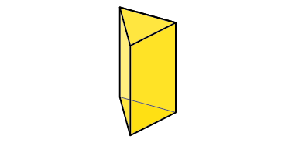  “The triangular prism has two faces with angles less than a right angle and three faces  with all right angles.”
Observations/Documentation

