Describing Events Using the Language of Chance
Thinks outcomes of an experiment are always equally likely to happen  “I choose green. The chance of getting any colour is always the same.” | Describes the likelihood of an event or outcome (e.g., impossible, likely, certain)  “It is likely that I will get red.” | Makes predictions based on likelihoods  “If I draw a marble 8 times and put it back each time, I predict I will get red 6 times.”
Observations/Documentation

Describing Events Using the Language of Chance (con’t)
Lists all possible outcomes for an experiment  “I could get green, blue, or red,  but not yellow or purple.” | Compares the likelihoods of two outcomes  “It is more likely that I will get blue than green.” | Identifies flexibly the likelihoods of outcomes in a simple probability experiment  “Blue is most likely, red is least likely, green is unlikely, and yellow is impossible.”
Observations/Documentation

Drawing Conclusions Based on Data
Asks and answers simple questions about an experiment  “If I toss the coin, I could get heads or tails. Getting heads or tails is equally likely.” | Makes simple decisions based on data  “I can roll a 1, 2, 3, 4, 5, or 6.  I would choose to roll a number less than 5 rather than a number greater than 5 because  I’m more likely to be right.” | Connects fairness of a game to equally-likely outcomes  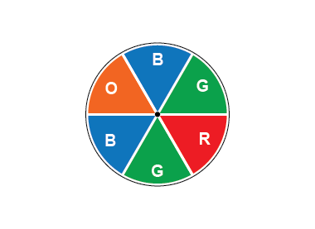  “There is an equal chance of landing on green or blue because they cover the same amount of space.  So, if I need to land on green and my partner on blue, the game is fair. In 12 spins, I expect the pointer to land on green 4 times  and on blue 4 times.” | Creates a game that is fair or unfair and justifies why it is or isn’t fair  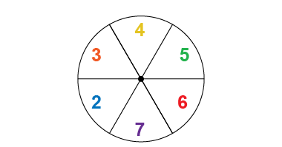  “Fair: rolling an even number or rolling an odd number because the outcomes are equally likely.”  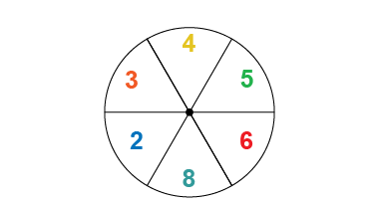  “Unfair: rolling an even number or rolling an odd number because it is more likely for the pointer to land on an even number.”
Observations/Documentation

