Collecting and Organizing Data
No organization of data  Which category of animals do you like best?  fish, mammals,  mammals, other,  birds, mammals,  fish, mammals,  mammals, fish | Uses class list; no interpretation  ✓ Juin Fish  Tommy  ✓ Tai Fish  ✓ Ioana Mammals  ✓ Mark Mammals  ✓ Alex Mammals  ✓ Kim Other  Jon  ✓ Sadia Fish  ✓ Lise Mammals  ✓ Dimitri Birds  Vicky  ✓ Ali Mammals  “I’m not sure which answer  was chosen most often.” | Organizes data using one attribute (e.g., tally chart, table, list, or line plot)  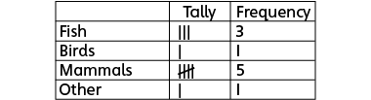  “I made a tally chart so I can easily see how many chose each answer.  Most students like mammals best.”
Observations/Documentation

Collecting and Organizing Data (con’t)
Organizes data using two attributes (e.g., two-way table, Venn diagram, Carroll diagram)  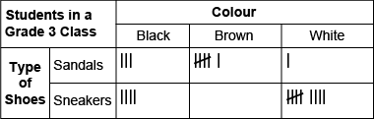 | Organizes data using three attributes (e.g., Venn diagram, tree diagram)  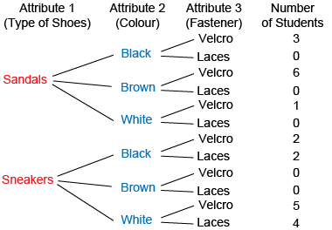 | Collects data and appropriately organizes them according to number of attributes  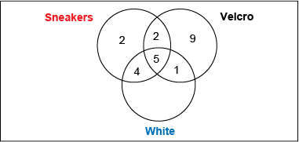
Observations/Documentation

