Divide Me! Instructions
Master 24

Group size: 2
Materials:
• Master 17: Divide Me! Game Cards
• Number cube, labelled 1−6
Goal: To be the first to have no cards left in your hand

Instructions:

Deal 6 cards each.
Place the remaining cards, face down, in a pile.
Player A: Roll the number cube.
Find a number in your hand that can be divided into groups
of that size (with no leftovers).

If you find a card, say the division sentence, then place
the card on the table.
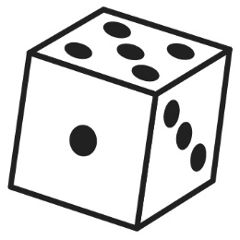
30
30 ÷ 5 = 6

If you can’t find a card, take a card from the pile.
Player B: Take a turn.
Continue to take turns until one of you has no cards left in
your hand.

