Place-Value Game Cards
Master 2a
Numerals
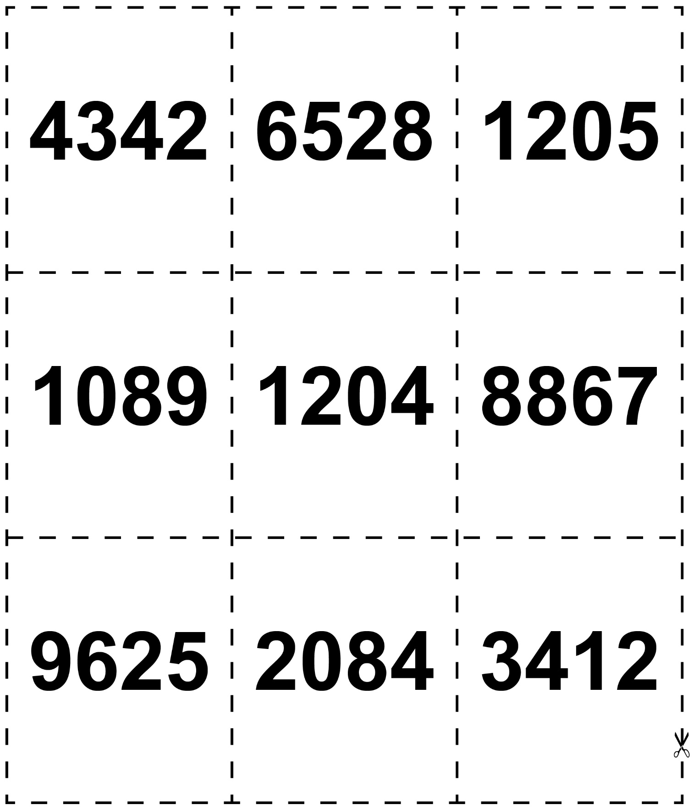
Place-Value Game Cards
Master 2b
Expanded Form
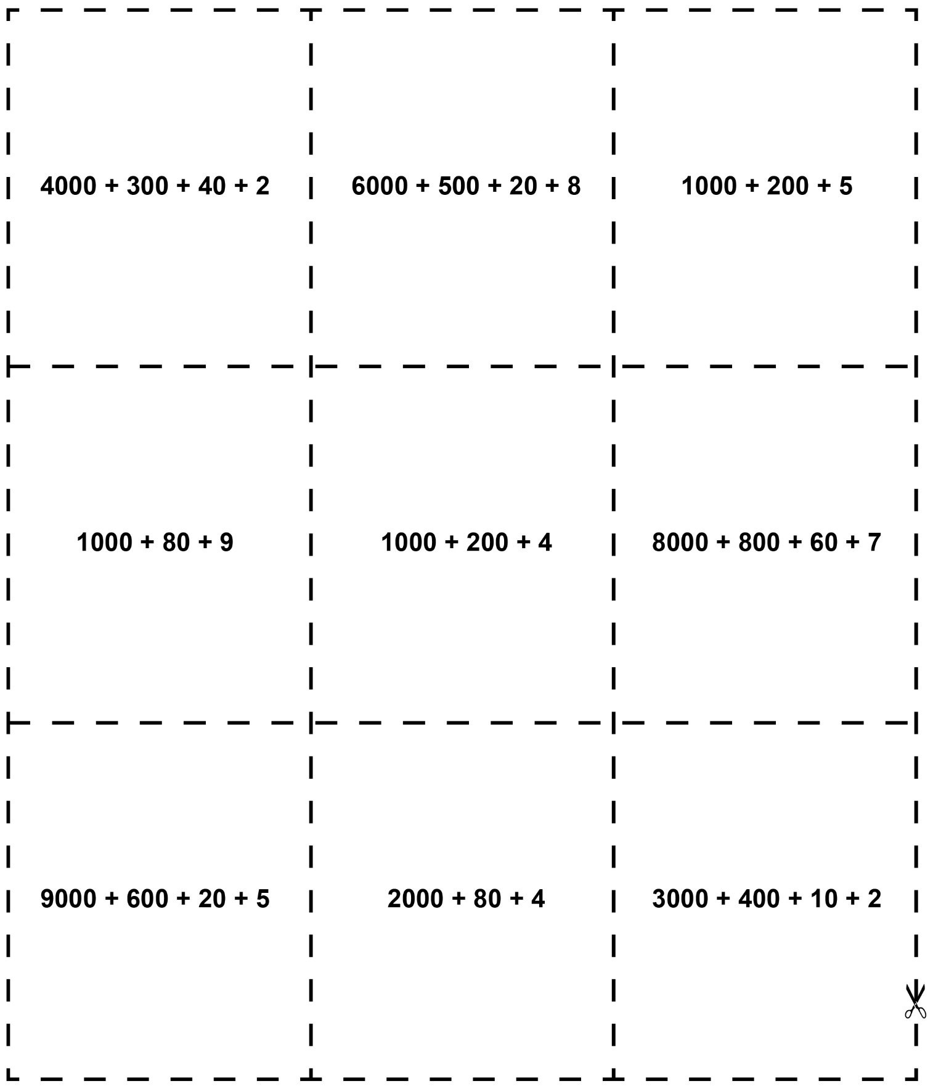
Place-Value Game Cards
Master 2c
Words
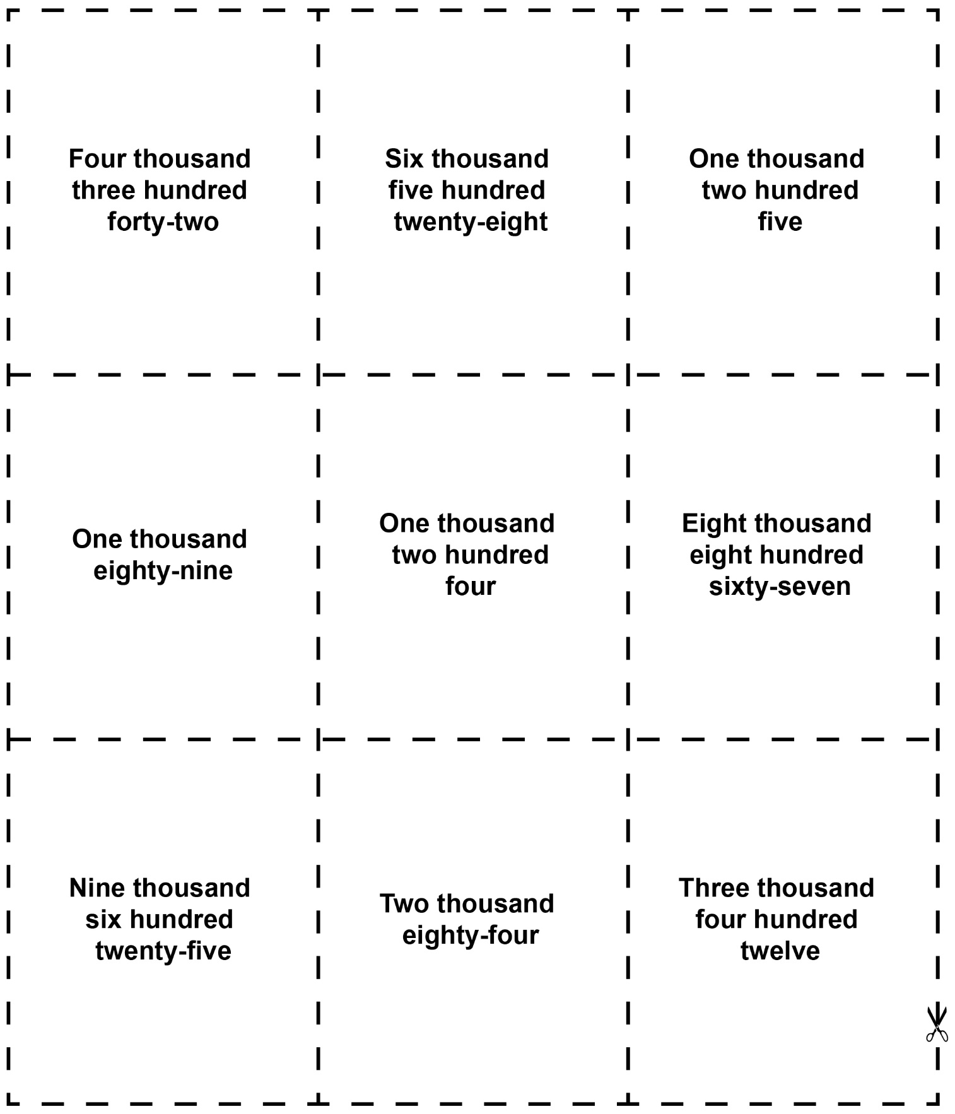

Place-Value Game Cards
Master 2d
Base Ten Blocks
