Master 57

Time Task A

Match each time with a clock, then write the time on a digital clock.

Times
a) two forty-two | b) 34 minutes before 5 | c) 10 minutes to 7
d) six fifty | e) 18 minutes to 3 | f) 26 minutes past 4

Clocks
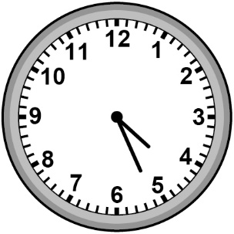 |  |  |  |  |  | 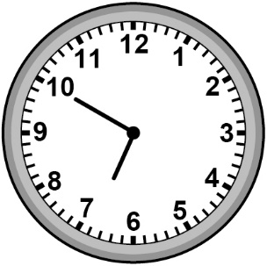 |  |  |  |  | 