Metres, Centimetres, or Millimetres?
Master 48a

Length of Pen  We will use  mm cm m  We will use  ruler or metre stick  Our measure is  ____________________________ | 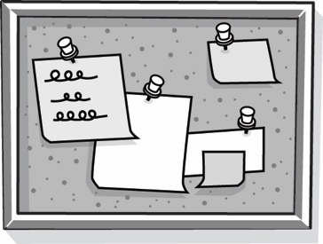  Length of Bulletin Board  We will use  mm cm m  We will use  ruler or metre stick  Our measure is  ____________________________
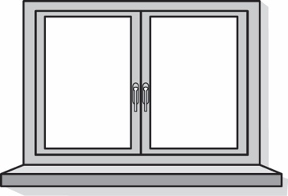  Length of Window Ledge  We will use  mm cm m  We will use  ruler or metre stick  Our measure is  ____________________________ | Pencil Point  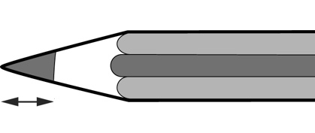  We will use  mm cm m  We will use  ruler or metre stick  Our measure is  ____________________________

Metres, Centimetres, or Millimetres? (for Extension)
Master 48b

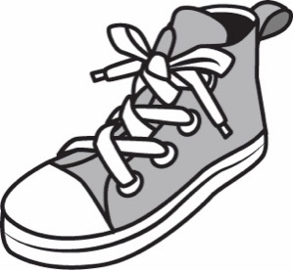  Length of Your Shoe  We will use  mm cm m  We will use  ruler or metre stick  Our measure is  ____________________________ | 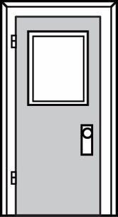  Height of Classroom Door  We will use  mm cm m  We will use  ruler or metre stick  Our measure is  ____________________________
Height of a Classmate  We will use  mm cm m  We will use  ruler or metre stick  Our measure is  ____________________________ | 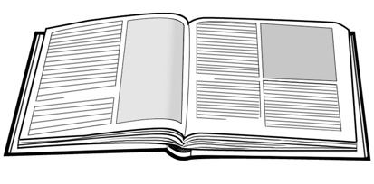  Width of a Letter in a Book  We will use  mm cm m  We will use  ruler or metre stick  Our measure is  ____________________________

