Stick Toss Game Setup Options
and Instructions
Master 74a

Photos of Materials
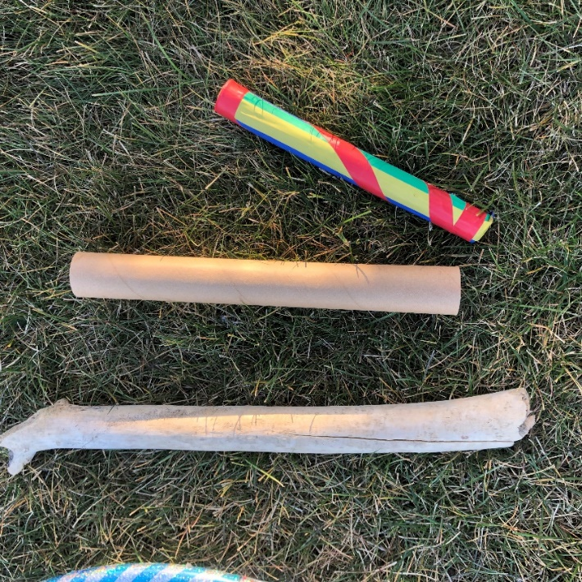

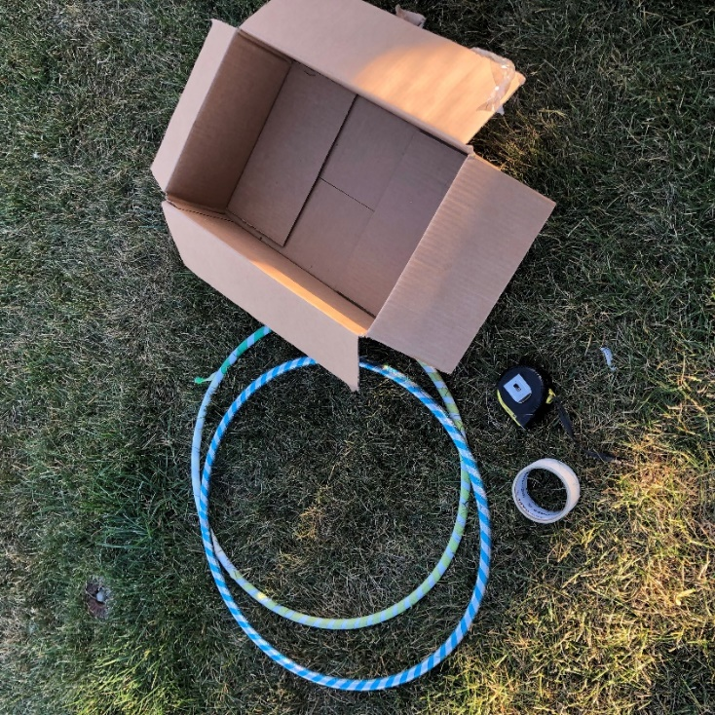
Sticks

Hula hoops, box, tape, measuring tape
Stick Toss Game Setup Options
and Instructions
Master 74b

Participants:
- Stick Gatherers (data recorders)
- Stick Tossers
- Caller (teacher, or students could take turns)
- Uplifters (all students should be encouraging others when it is not their turn)

Setup:
See the diagrams of 4 possible ways to set up the game on the pages that follow.

For example:
- Mark sections on the ground to determine points.
Create a point system per targeted section.
- Points may correlate with numeracy reinforcement; for example, the closest section: 10 points; mid-section: 100 points; farthest section: 1000 points.
- Determine the number of tosses each student gets.
- Determine whether Stick Tossers get to practise before data are recorded.
- The Stick Gatherers (data recorders) record the number of points per toss.
- Divide students into pairs: Stick Tosser and Stick Gatherer.
- 4 or more Stick Tossers toss from a marked line on the ground at the same time, while others stand in line and wait for their turn.

Stick Toss Game Setup Options
and Instructions
Master 74c

Using Hula Hoops
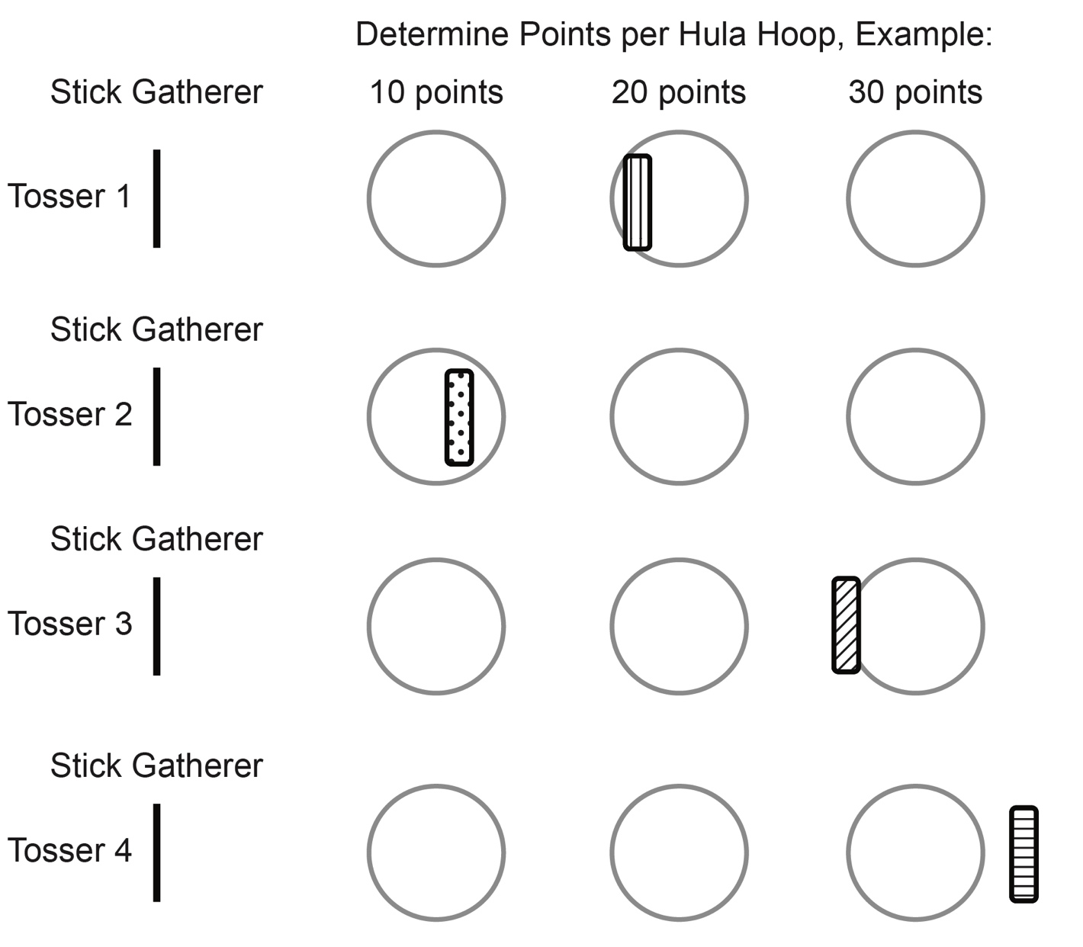
Toss and Hula Hoop Target

Stick Toss Game Setup Options
and Instructions
Master 74d

Using Lines (tape or sticks)
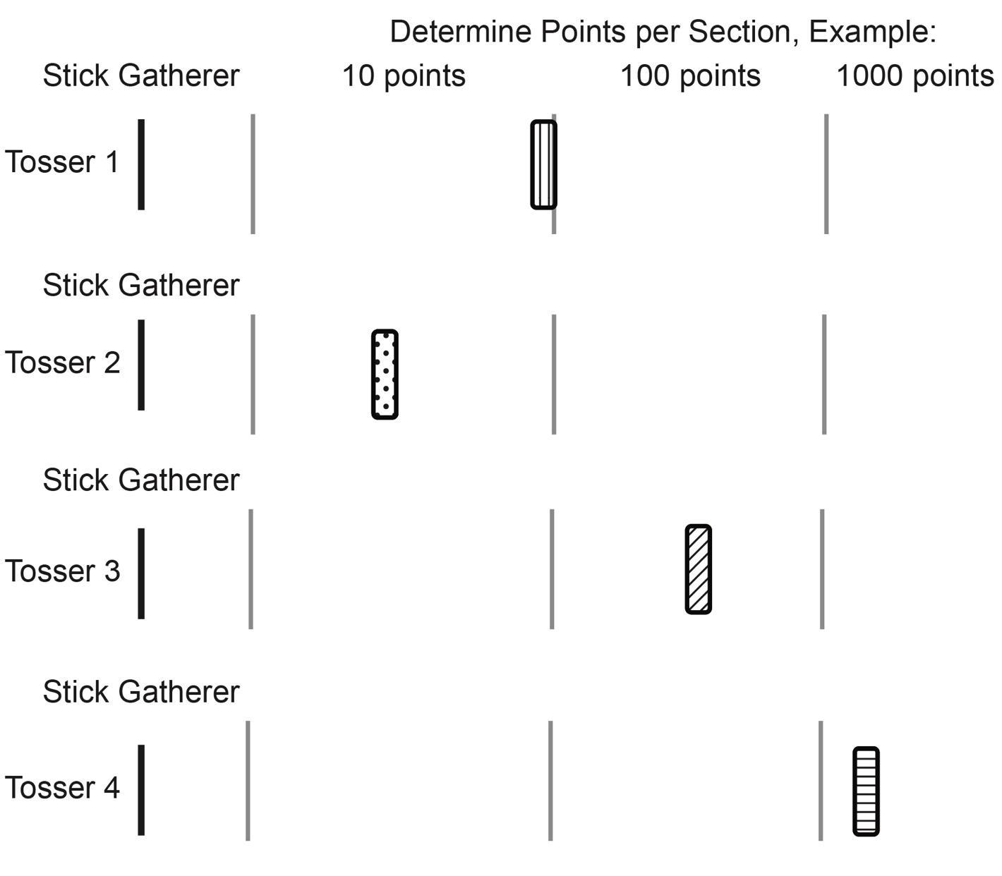
Toss and Section Points

Stick Toss Game Setup Options
and Instructions
Master 74e

Measuring Distance
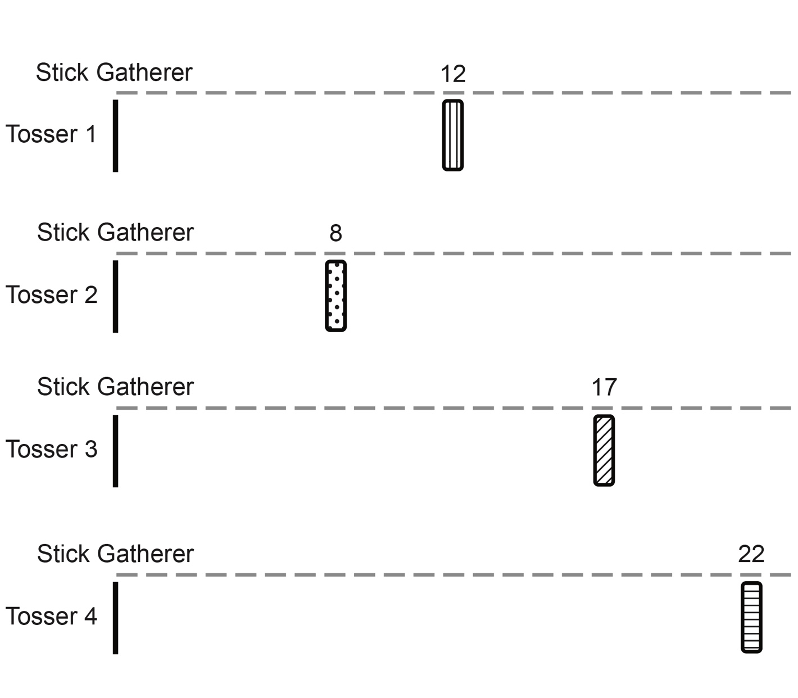
Toss and Measure

Stick Toss Game Setup Options
and Instructions
Master 74f

Tossing to a Bucket (bucket, bin, or box)

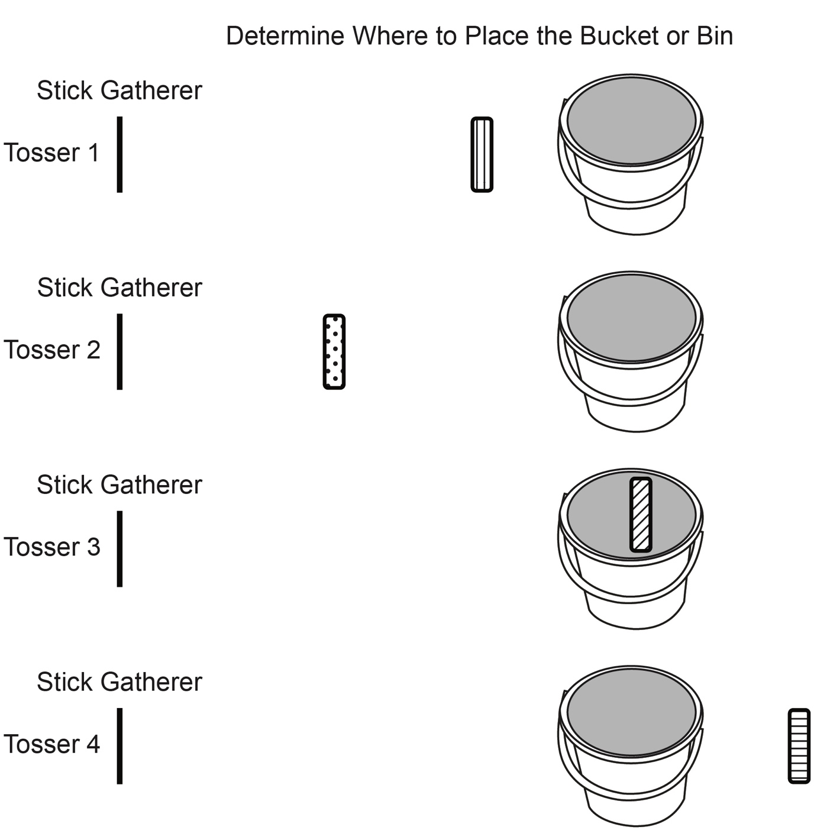

Toss and Get in Bucket
How many tries did it take?

