Partitioning Quantities to Form Fractions
Partitions whole (area or length) into parts that are not equal  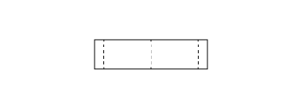  “I folded the strip into 4 parts.” | Partitions whole (area or length) into equal parts  “I folded the line into 4 equal parts.” | Names the unit fraction  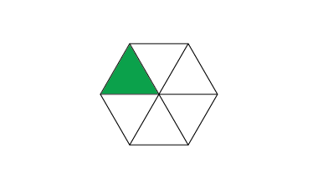  “Each part represents one-sixth.” | Counts parts using unit fractions  “1 one-fourth, 2 one-fourths,  3 one-fourths, 4 one-fourths”
Observations/Documentation

Partitioning Quantities to Form Fractions (con’t)
Compares fractions to the benchmark one-half  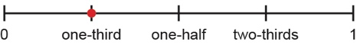  “One-third is less than the benchmark one-half.” | Understands relationship between number of parts and size of parts  “When I divide the whole into more parts, the parts get smaller. | Uses fraction symbol to represent fractional quantities of whole  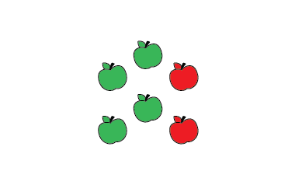  “$\frac{4}{6}$of the apples are green.” | Compares fractions with the same denominator or same numerator  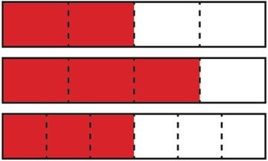  “$\frac{3}{4}$> $\frac{2}{4}$because one more part is shaded.”  “$\frac{3}{4}$> $\frac{3}{6}$because fourths are larger than sixths.”
Observations/Documentation

