Representing Numbers Using Place Value
Models 3-digit number using Base Ten Blocks (decomposes in one way)  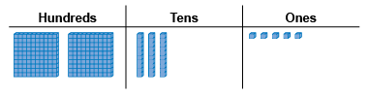  “I modelled 235. I used the digits of the number to tell me how many of each block I needed.” | Models 3-digit number (decomposes in more than one way) and records using place-value names  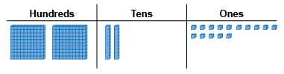  “two hundred thirty-five:  I can also show it as 2 hundreds,  2 tens and 15 ones if I trade 1 ten for 10 ones.” | Models 4-digit number using Base Ten Blocks (decomposes in one way)  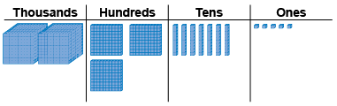  “I modelled 2375. I used the digits of the number to tell me how many of each block I needed.”
Observations/Documentation

Representing Numbers Using Place Value (cont’d)
Systematically models 4-digit number in more than one way using patterns and place-value relationships  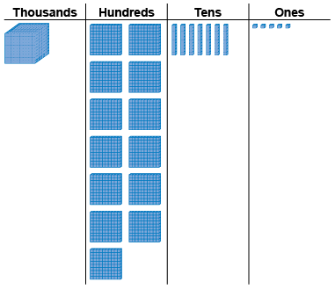  “I traded one thousand cube  for 10 hundred flats.” | Models 4-digit number in more than one way and records each way in expanded form  “2375 = 1000 + 1300 + 70 + 5” | Represents numbers flexibly using place-value relationships  “2375 = 2000 + 300 + 70 + 5  2375 = 2000 + 300 + 60 + 15  2375 = 2000 + 300 + 50 + 25  2 thousands, 3 hundreds, 4 tens, 35 ones”
Observations/Documentation

Comparing and Ordering Quantities
Models numbers and compares blocks  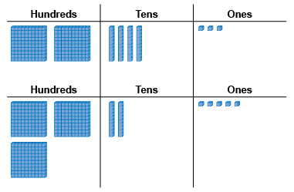  “325 has one more hundred flat,  so it is greater than 243.” | Compares numbers with benchmarks  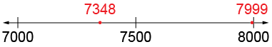  “I compared the numbers to 7500. 7348 is less than 7500 and 7999 is almost 8000.  So, 7999 is greater.” | Visualizes benchmarks on a number line to compare  “I picture 7999 farther to the right on the line than 7348. So, 7999 is greater than 7348.”
Observations/Documentation

Comparing and Ordering Quantities (cont’d)
Uses place value understanding to compare numbers, digit by digit  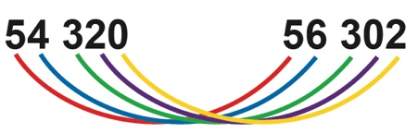  “Both start with 5.  4 thousands is less than 6 thousands,  both have 3 hundreds,  2 tens is greater than 0 tens,  and 0 ones is less than 2 ones.  So, 54 320 is less than 56 302.” | Compares and orders three or more numbers using a variety of strategies  54 320 56 302 35 560  “I first compare using ten thousands,  then compare 54 320 and 56 302 using thousands.” | Compares numbers flexibly and records comparisons symbolically (<, =, >)  54 320 < 56 302  “Both numbers have 5 ten thousands,  but 56 302 has more thousands.”
Observations/Documentation

