Reading and Interpreting Data Displays
Notices the basic shape of graph  “This bar is the longest. This bar is the shortest.” | Counts symbols or squares to read data  “1, 2, 3, …, 10, 11, 12 squares are shaded. Henrietta laid 12 eggs.” | Uses scale to read data  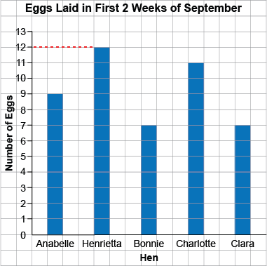  “The bar has height 12. Henrietta laid  12 eggs.”
Observations/Documentation

Reading and Interpreting Data Displays (con’t)
Makes direct comparisons between data  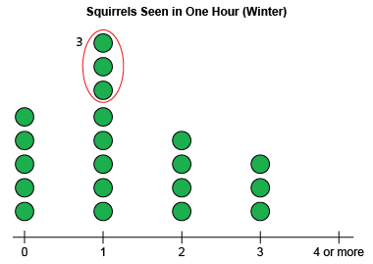  “1 squirrel was seen 3 more times than  0 squirrels.” | Uses data to answer some questions  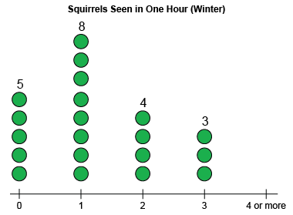  “5 + 8 + 4 + 3 = 20; 20 students were surveyed.” | Draws conclusions from data  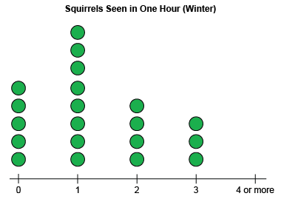  “Most students saw 1 squirrel in one hour in the winter.”
Observations/Documentation

