**Kokum’s Bannock** **Line Master 1** (Assessment Master)

**Name:** _____________________________

|  |  |  |  |
| --- | --- | --- | --- |
| **Model and Describe Equality and Inequality** | **Not observed** | **Sometimes** | **Consistently** |
| Models and describes examples of equality (balance; the same as) and inequality (imbalance; not the same as) |  |  |  |
| Recognizes, uses, and understands the equal (=) and not equal (≠) symbols when comparing expressions |  |  |  |
| Records different expressions of the same quantity as equalities |  |  |  |
| **Explore Properties of Addition and Subtraction** |  |  |  |
| Decomposes and combines numbers to write addition and subtraction equations in different forms |  |  |  |
| Investigates addition and subtraction as inverse operations |  |  |  |
| Explores and solves for missing addends and subtrahends |  |  |  |

**Strengths:**

**Next Steps:**

**Connecting Home and School Line Master 2–1**

**NOTE TO THE TEACHER**

You may wish to send families a ***Kokum’s Bannock*** letter outlining a familiar activity or two they can do at home with their children.

Create a letter using this template and select one or two activities from the suggestions on the next page. Simply **delete these instructions and cut and paste the activities you have selected**, adapting them to fit your needs.

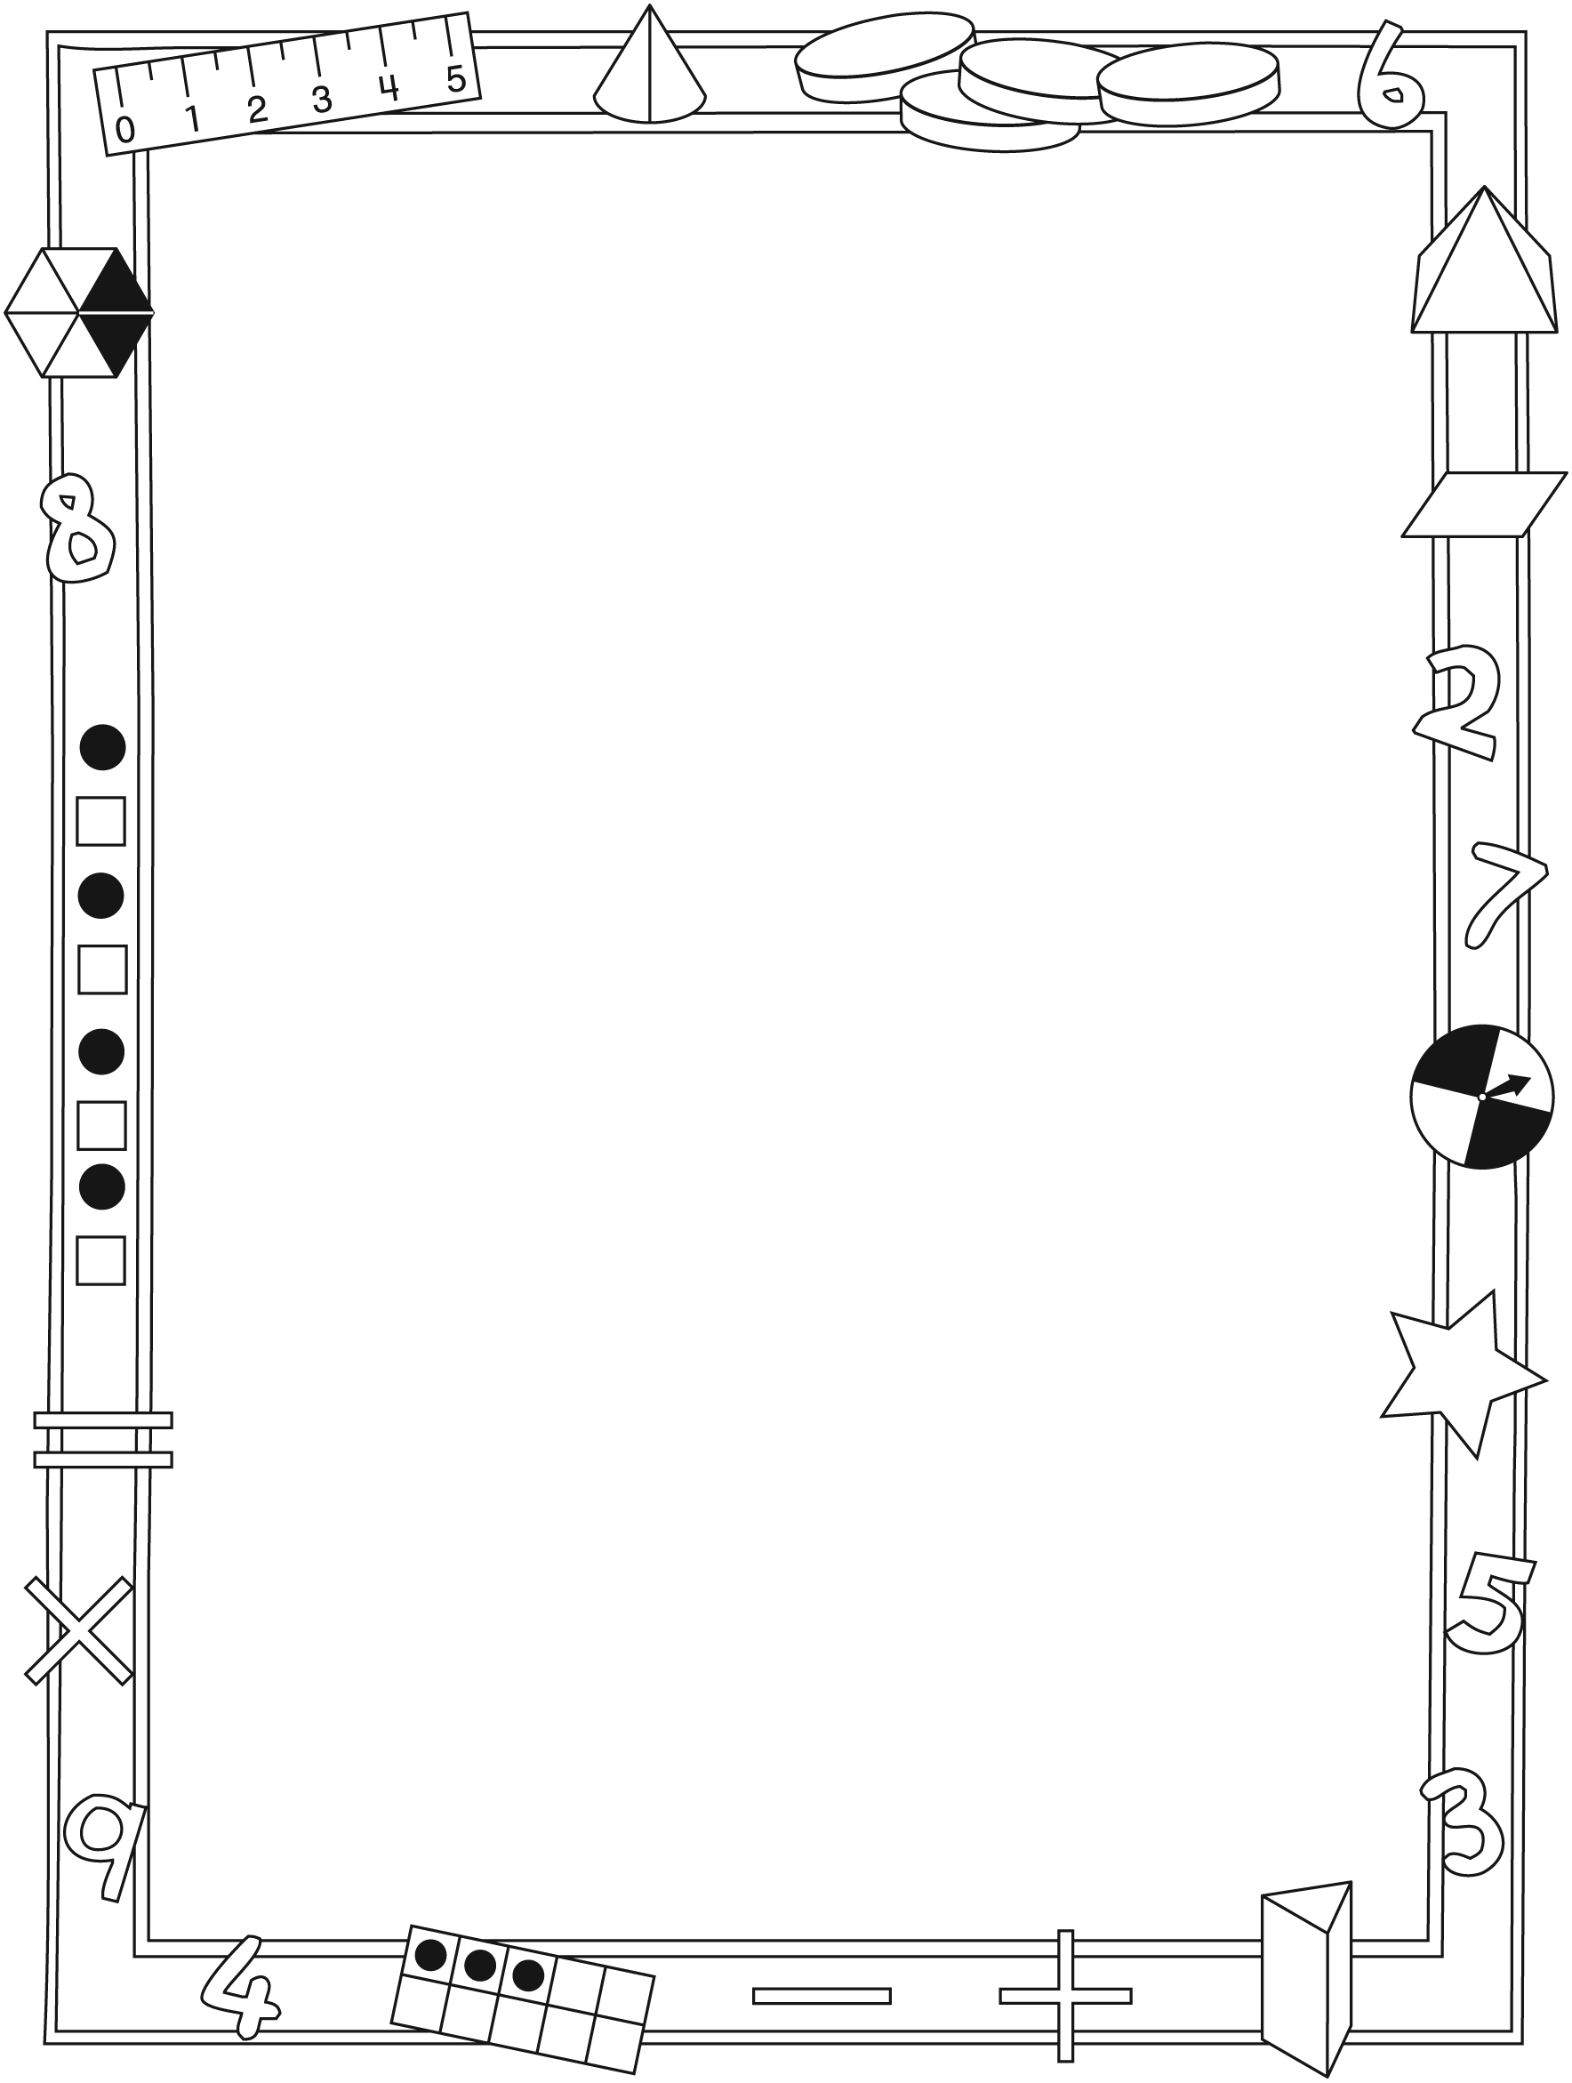

**Connecting Home and School Line Master 2–2**

Dear Family:

We have been working on ***Kokum’s Bannock***, which engages children in conversations, investigations, and activities that help to develop their understanding of the big math idea that “Symbols and expressions can be used to represent mathematical relations.” Particular focus is placed on modelling and describing equality and inequality, and exploring properties of addition and subtraction. Try this activity at home with your child.

✂ – – – – – – – – – – – – – – – – – – – – – – – – – – – – – – – – – – – – – – – – – –

**Reading the Story:** As you read the story, encourage your child to identify and describe equal groups. Invite her/him to count the number of animals and compare scoops when making bannock. Model using the terms *equal/not equal, balanced/imbalanced*, and *the same as/not the same as* when describing the story.

✂ – – – – – – – – – – – – – – – – – – – – – – – – – – – – – – – – – – – – – – – – – –

**How Many Ways?** Roll a number cube, select a number card, or suggest a number between 1 and 10. Challenge your child to come up with as many different ways as he/she can to make the selected number using addition and/or subtraction. Start with using 2 numbers only (e.g., 4 = 2 + 2) and increase the amount of numbers as appropriate (e.g., 4 = 2 + 1 + 1). Record responses to ensure there are no repeats.

✂ – – – – – – – – – – – – – – – – – – – – – – – – – – – – – – – – – – – – – – – – – –

**Domino Pairs:** Start by selecting 2 dominoes and adding them together. Challenge your child to use 2 different dominoes to make the same final answer. Replace your dominoes in the pile and take turns going first.

✂ – – – – – – – – – – – – – – – – – – – – – – – – – – – – – – – – – – – – – – – – – –

**Equal I Spy:** On your way to school or home, invite your child to play a game of   
I Spy to identify equal pairs. For example, if your child sees 2 black cars and 2 bicycles, he/she might say, “I spy 2 pairs of things with wheels.” Ensure that you or your child has identified both pairs before starting each round and asking the other to guess.

✂ – – – – – – – – – – – – – – – – – – – – – – – – – – – – – – – – – – – – – – – – – –

Sincerely,

___________________________

***Kokum’s Bannock* Line Master 3**

**Math Mat**

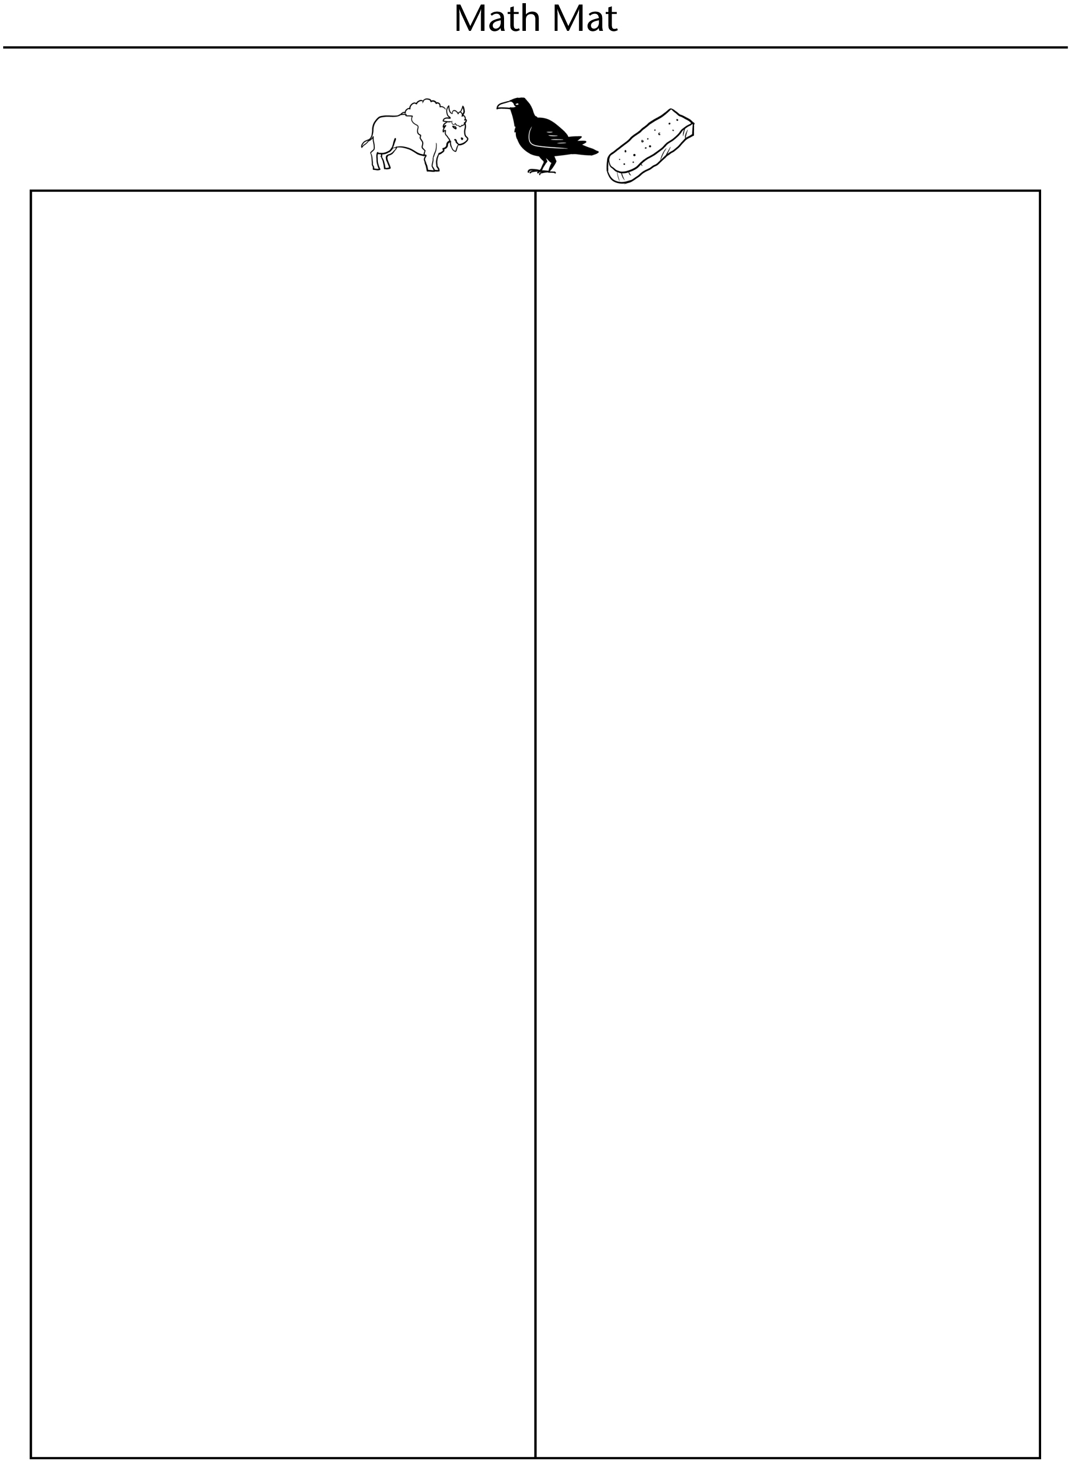

**Equal or Not Equal Line Master 4**

**Name:** _____________________________



|  |  |
| --- | --- |
| **______ ______** | **______ ______** |
| **______ ______** | **______ ______** |
| **___ + ___ ___ + ___** | **___ + ___ ___ + ___** |
| **___ + ___ ___ + ___** | **___ + ___ ___ + ___** |

**Balancing Numbers Line Master 5**

**Name:** _____________________________

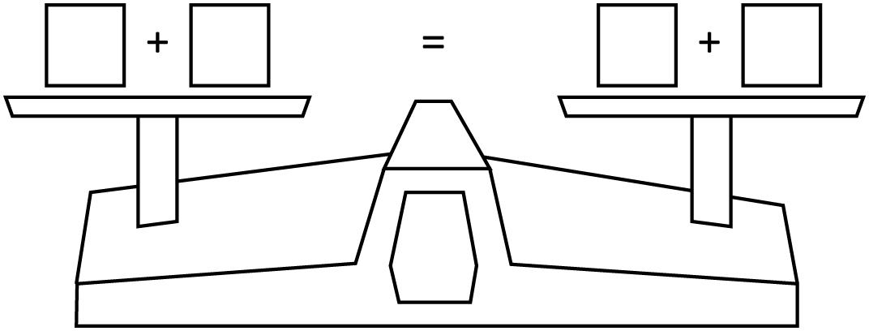

✂ – – – – – – – – – – – – – – – – – – – – – – – – – – – – – – – – – – – – – – – – – –

**Name:** _____________________________



✂ – – – – – – – – – – – – – – – – – – – – – – – – – – – – – – – – – – – – – – – – – –

**Find the Missing Number Line Master 6**

**Name:** _____________________________

|  |  |
| --- | --- |
| **5 + ___ = 7** | **10 + ___ = 13** |
| **3 + ____ = 8** | **4 + ____ = 8** |
| **2 + ___ = 6** | **5 + ____ = 15** |
| **13 = 7 + ____** | **20 = 9 + ___** |
| **12 = 5 + ____** | **11 = 6 + ____** |

**Memory Cards Line Master 7–1**

Set 1



|  |  |
| --- | --- |
| **6** | **3 + 3** |
| **10** | **6 + 4** |
| **8** | **3 + 5** |
| **5** | **3 + 2** |
| **7** | **3 + 4** |

**Memory Cards Line Master 7–2**

Set 2



|  |  |
| --- | --- |
| **6 + 1** | **3 + 4** |
| **10 + 2** | **6 + 6** |
| **8 + 1** | **4 + 5** |
| **5 + 5** | **6 + 4** |
| **7 + 4** | **5 + 6** |

**Memory Cards Line Master 7–3**

Set 3



|  |  |
| --- | --- |
|  | **3 + 2** |
|  | **6 + 2** |
|  | **3 + 1** |
|  | **2 + 7** |
|  | **5 + 1** |

**Memory Cards Line Master 7–4**

Set 4



|  |  |
| --- | --- |
| **6 + 1** | **10 − 3** |
| **10 + 2** | **14** **− 2** |
| **8 + 1** | **15 − 6** |
| **5 + 5** | **20 − 10** |
| **7 + 4** | **15 − 4** |

**How Many Ways? Line Master 8**

**Name:** _____________________________

My number is: _____________________________

|  |
| --- |
| I can make it these ways: |

✂ – – – – – – – – – – – – – – – – – – – – – – – – – – – – – – – – – – – – – – – – – –

**Name:** _____________________________

My number is: _____________________________

|  |
| --- |
| I can make it these ways: |

✂ – – – – – – – – – – – – – – – – – – – – – – – – – – – – – – – – – – – – – – – – – –

**Our Class Book Line Master 9**

**Name:** _____________________________

|  |  |
| --- | --- |
|  |  |

__________ Equals ___________

______________________________________________________________________________

______________________________________________________________________________

______________________________________________________________________________

______________________________________________________________________________

______________________________________________________________________________

______________________________________________________________________________

______________________________________________________________________________

**Math Problems Line Master 10–1**

✂ – – – – – – – – – – – – – – – – – – – – – – – – – – – – – – – – – – – – – – – – – –

Find the missing number.

8 + _____ = 12

Explain how you know.

✂ – – – – – – – – – – – – – – – – – – – – – – – – – – – – – – – – – – – – – – – – – –

Find the missing number.

9 **−** _____ = 5

Explain how you know.

✂ – – – – – – – – – – – – – – – – – – – – – – – – – – – – – – – – – – – – – – – – – –

**Math Problems Line Master 10–2**

✂ – – – – – – – – – – – – – – – – – – – – – – – – – – – – – – – – – – – – – – – – – –

6 + 6 = 12

Write another addition sentence with the same answer.

Explain how you know.

✂ – – – – – – – – – – – – – – – – – – – – – – – – – – – – – – – – – – – – – – – – – –

11 **−** 6 = 5

Write another subtraction sentence with the same answer.

Explain how you know. 

✂ – – – – – – – – – – – – – – – – – – – – – – – – – – – – – – – – – – – – – – – – – –