What Would You Rather? Line Master 1
(Assessment Master)

Name: _____________________________

Compare Quantities to 100 | Not observed | Sometimes | Consistently
Determines how many more/less one quantity is compared to another
Uses relevant benchmarks to make mental comparisons and estimate quantities
Estimate and Count to 100
Skip-counts by factors of 10 (2, 5, 10) and multiples of 10
Skip-counts by factors of 100
(20, 25, 50)
Estimates and counts by different ways to 100
Strengths:

Next Steps:

Connecting Home and School Line Master 2–1



NOTE TO THE TEACHER

You may wish to send families a What Would You Rather? letter outlining a familiar activity or two they can do at home with their children.

Create a letter using this template and select one or two activities from the suggestions on the next page. Simply delete these instructions and cut and paste the activities you have selected, adapting them to fit your needs.

Connecting Home and School Line Master 2–2

Dear Family:

We have been working on What Would You Rather?, which focuses on comparing quantities to 100 and estimating and counting to 100. Try this activity at home with your child.

 – – – – – – – – – – – – – – – – – – – – – – – – – – – – – – – – – – – – – – – – – –

Reading the Story: As you read the story, enjoy estimating, counting, and comparing the objects and creatures on each page. Each set is close in number, so prepare to be surprised!

 – – – – – – – – – – – – – – – – – – – – – – – – – – – – – – – – – – – – – – – – – –

Spiders Galore! After you read, use the Math Mat (on the inside back cover of the book) to create counting stories of spiders in a web. Have your child close his/her eyes while you create sets of equal size on the web, and then have her/him estimate and count to see how many spiders there are. Have fun!

 – – – – – – – – – – – – – – – – – – – – – – – – – – – – – – – – – – – – – – – – – –

All Set Up! Gather a collection of 100 objects. They can be buttons, coins, counters, or even dried beans or pasta. Have your child count them to be
sure of the total. Next, choose a number for each set—either 2, 5, 10, 20, or 25—and have your child break up the 100 objects into groups of that size.
Next, he/she should skip-count to find the total (e.g., 10, 20, 30...), touching each group while saying the corresponding number. Trade roles and play too!

 – – – – – – – – – – – – – – – – – – – – – – – – – – – – – – – – – – – – – – – – – –

Ten Snap! Quietly count to 100 by 1s. As you reach multiples of 10 (10, 20, 30, 40, etc.), call out the number and snap your fingers. Play again with the multiples of 5 (5, 10, 15, 20, 25…). For a challenge, start at a different number!

 – – – – – – – – – – – – – – – – – – – – – – – – – – – – – – – – – – – – – – – – – –

Sincerely,

___________________________
What Would You Rather? Line Master 3
Math Mat

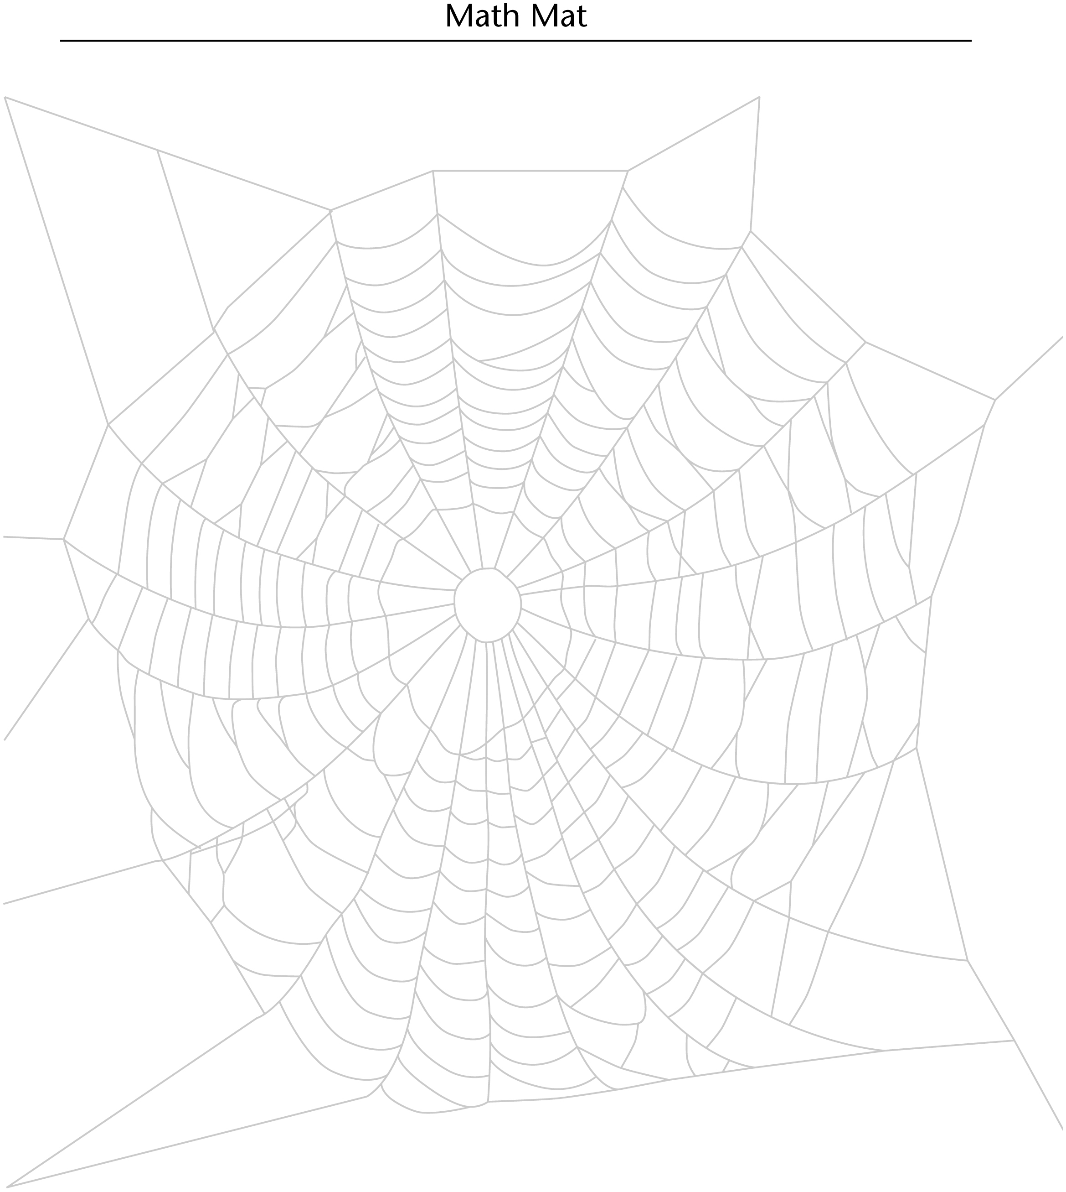

More or Less Spinner Line Master 4

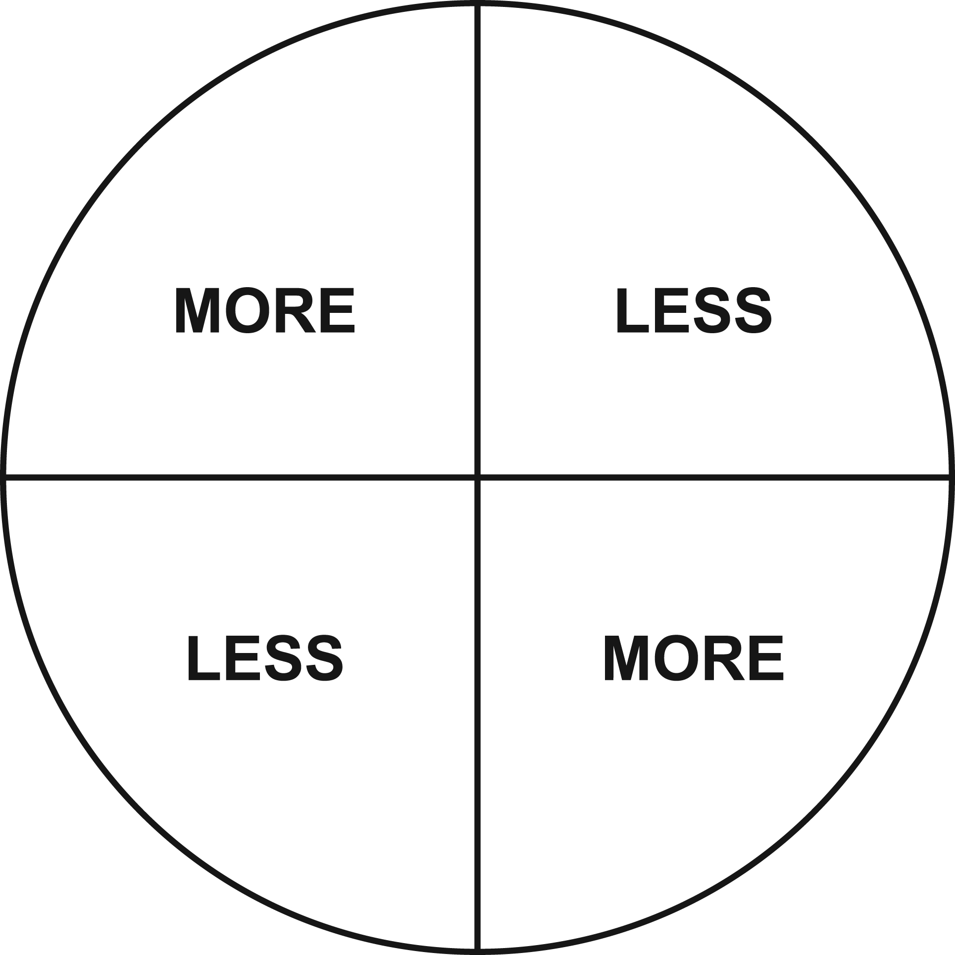

Hundred Chart Line Master 5

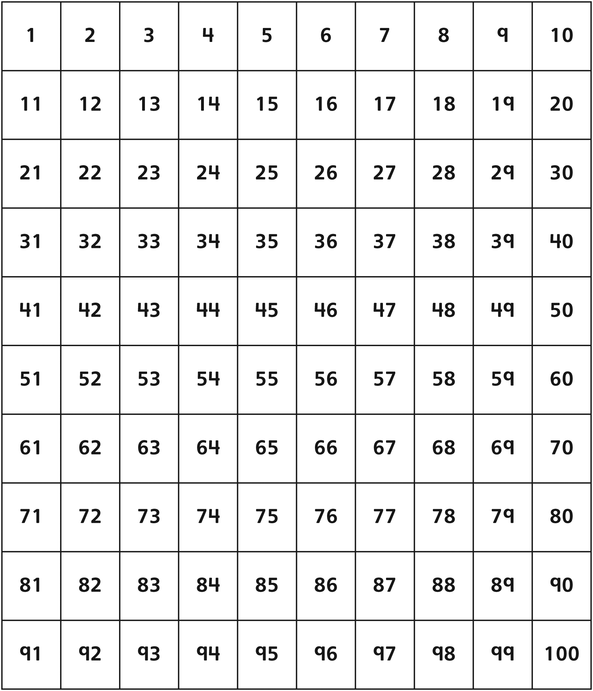

My Page Line Master 6–1
Name: _____________________________



Hey, _______________________________________________,

what would you rather…?
My Page Line Master 6–2
Name: _____________________________



