Find the Missing Number Cards
Master 43a

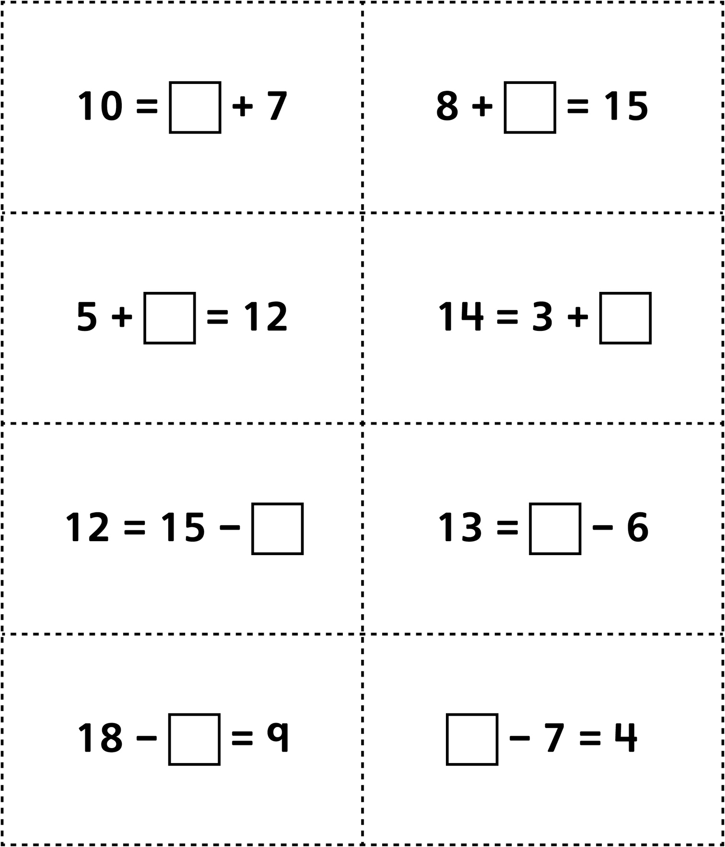

Find the Missing Number Cards
Master 43b

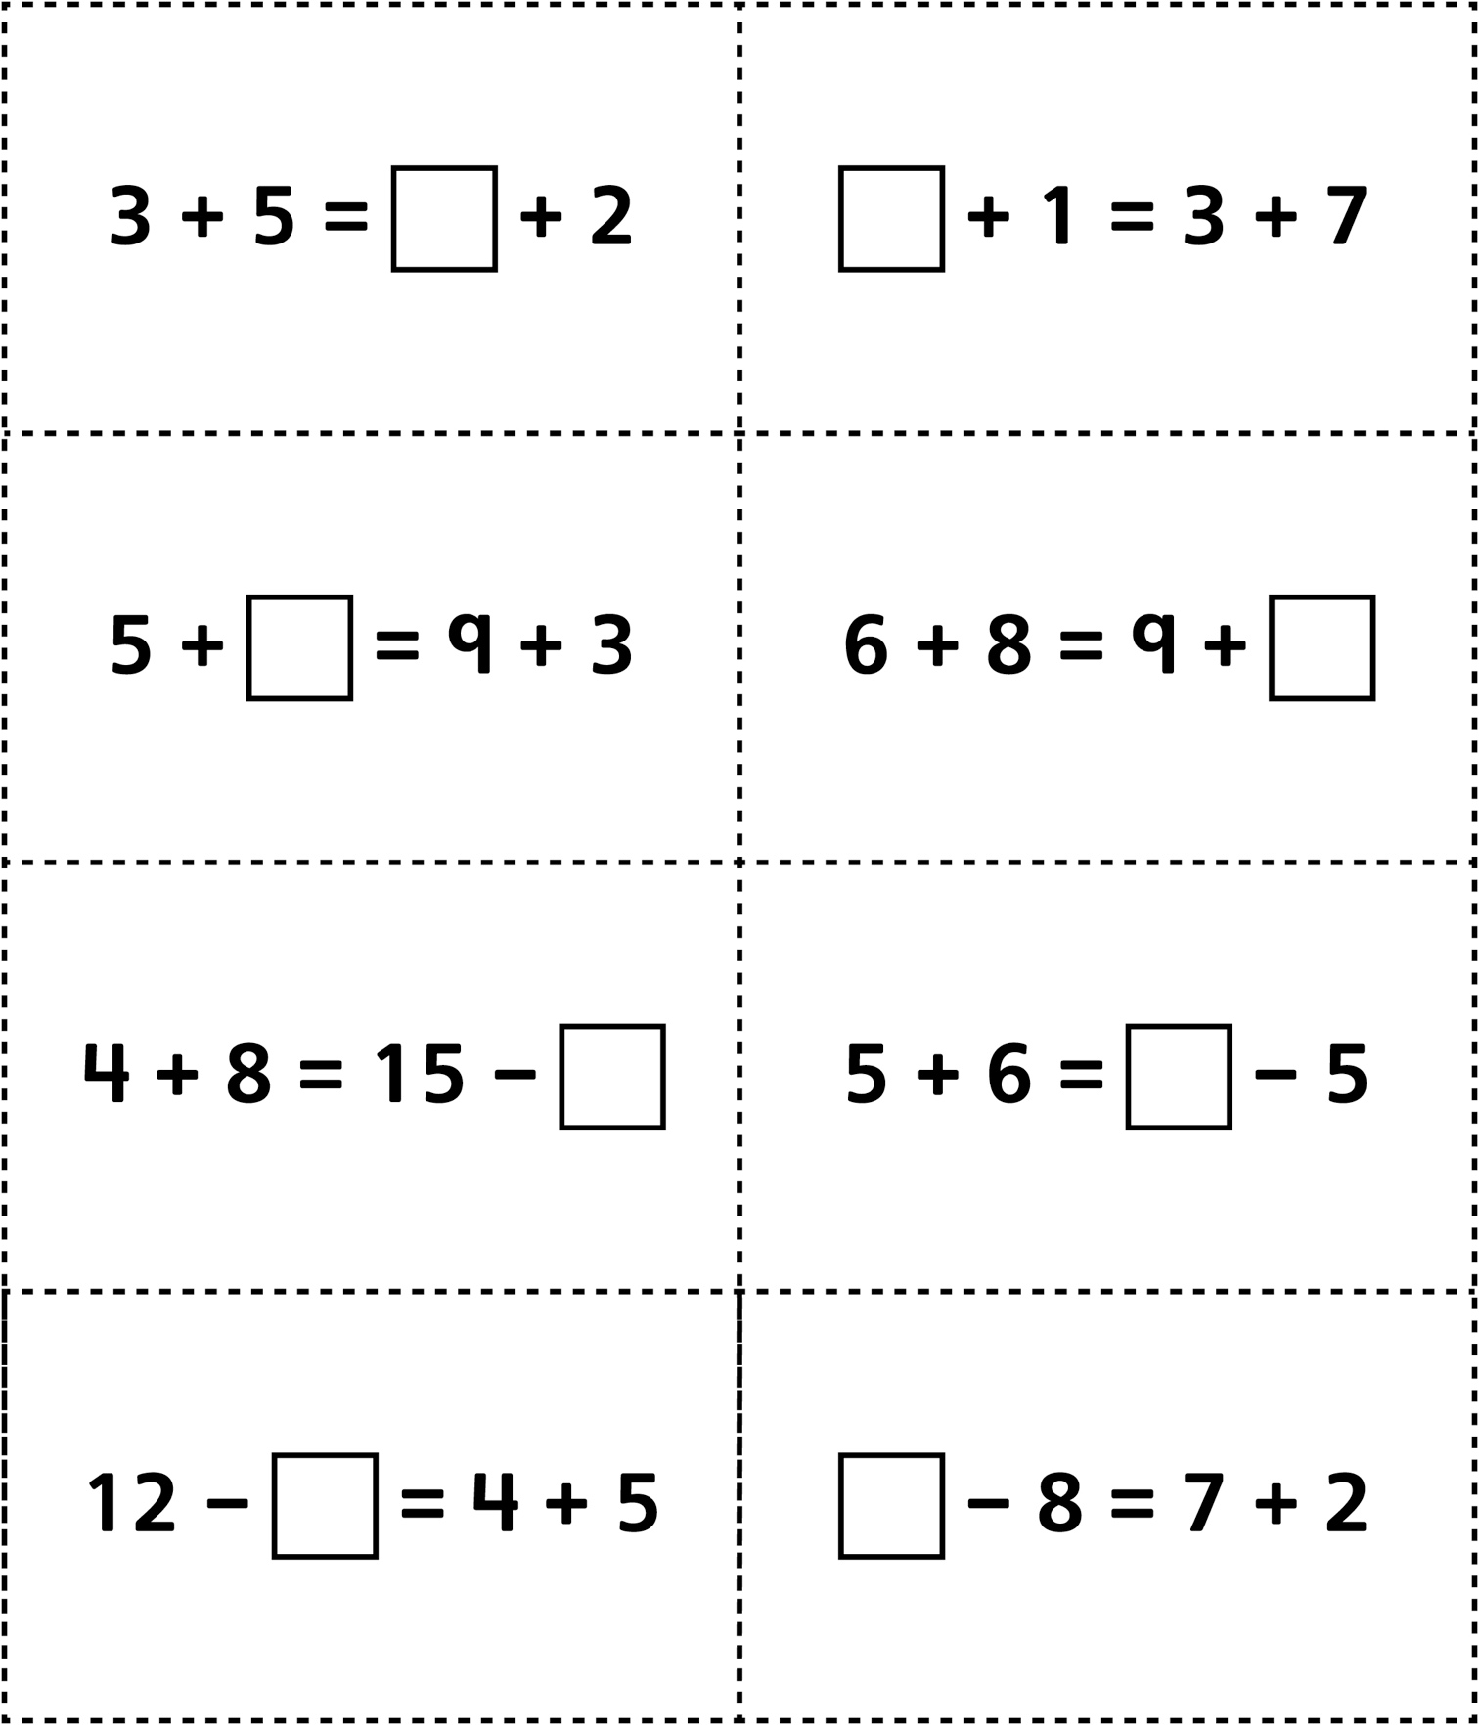

Find the Missing Number Cards
Master 43c

(for Accommodations)
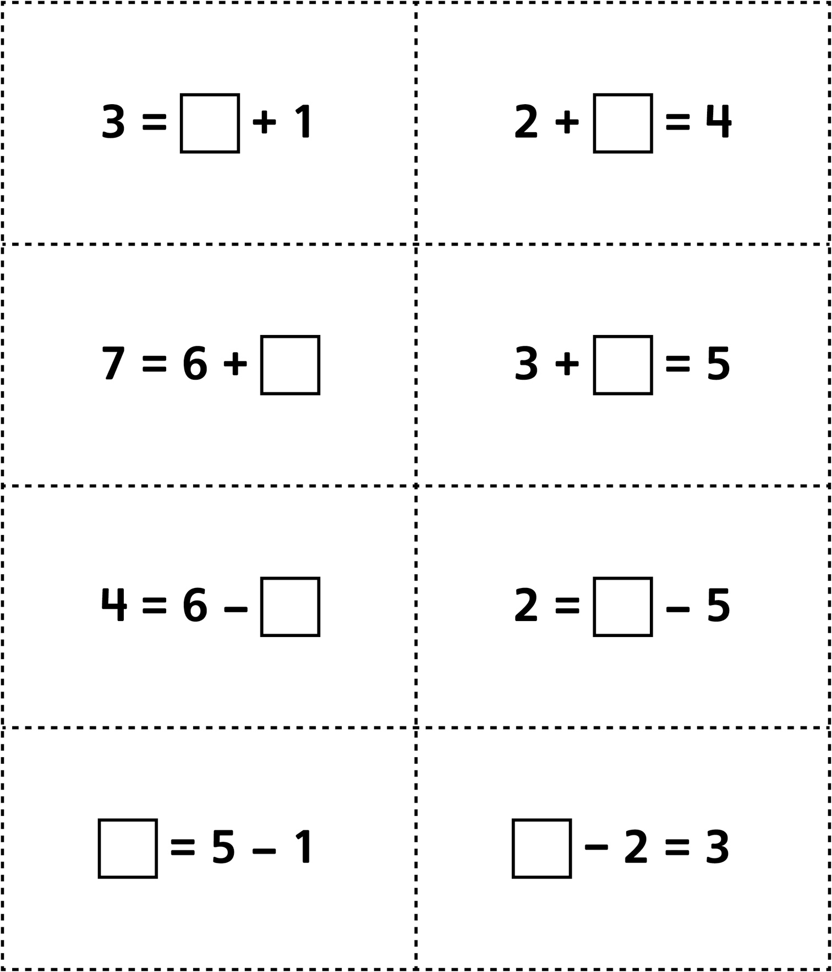
Find the Missing Number Cards
(for Combined Grades Extension)
Master 43d

