**Equal Match Cards**

**Master 41a**

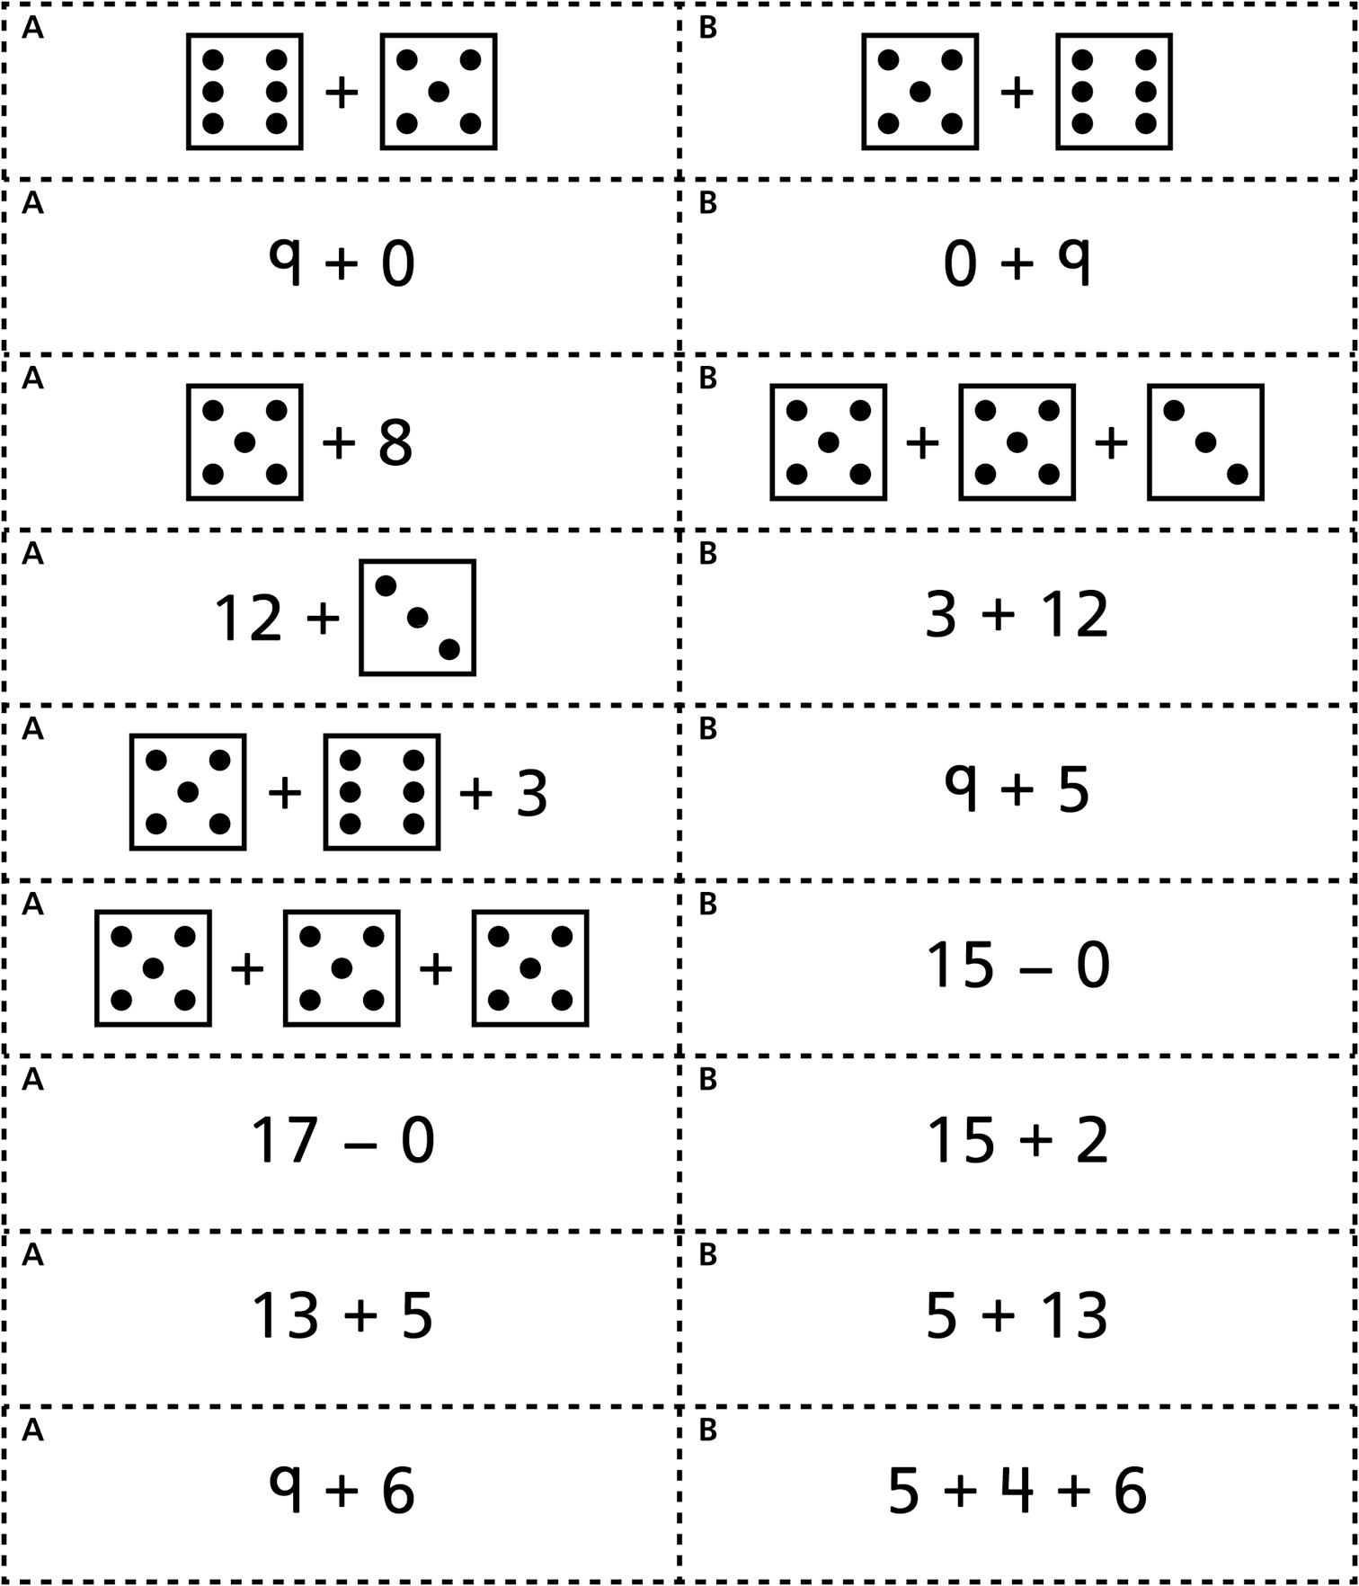

**Equal Match Cards   
(for Accommodations)**

**Master 41b**

