Equal or Not Equal? Number Sentences
Master 38a

Write = or ≠ in each box.
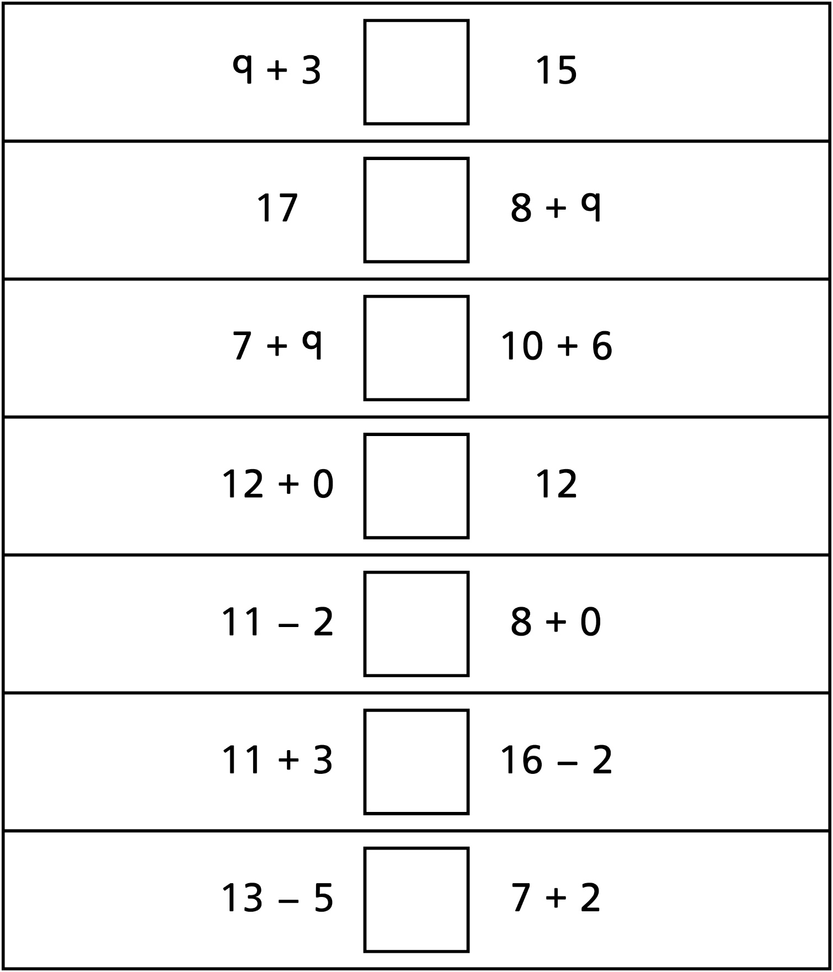
Equal or Not Equal? Number Sentences
Master 38b

(for Accommodations)
Write = or ≠ in each box.
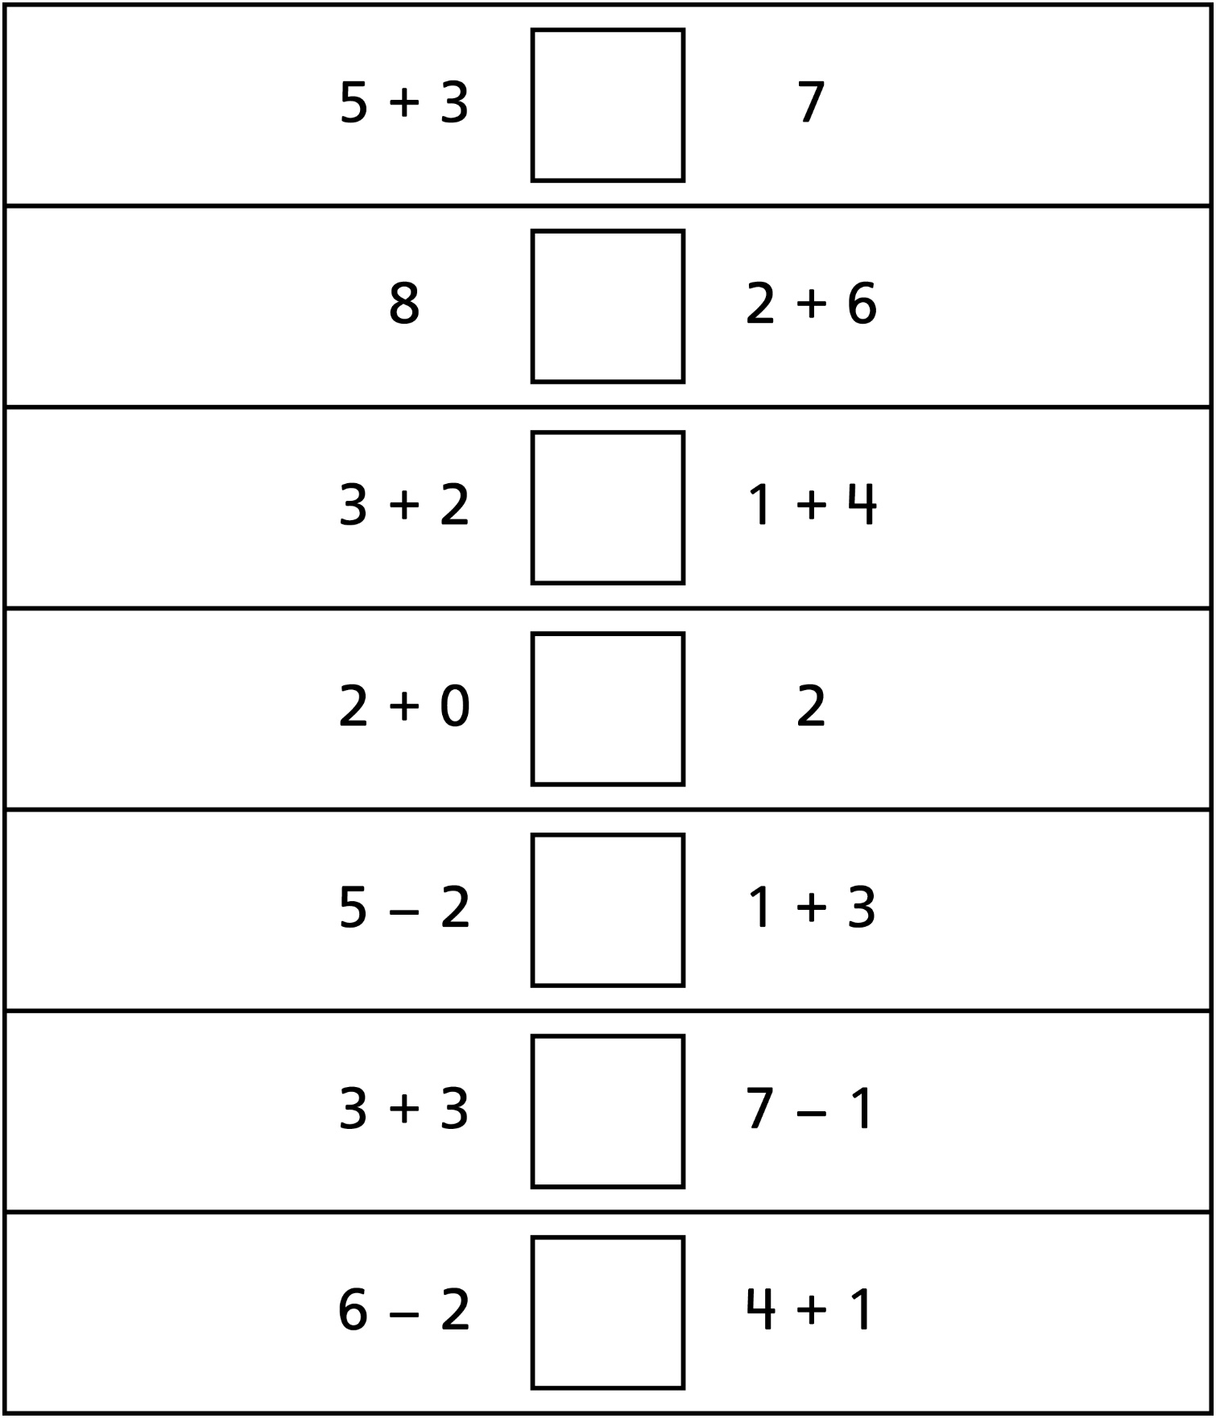
Equal or Not Equal? Number Sentences
Master 38c

(for Combined Grades Extension)
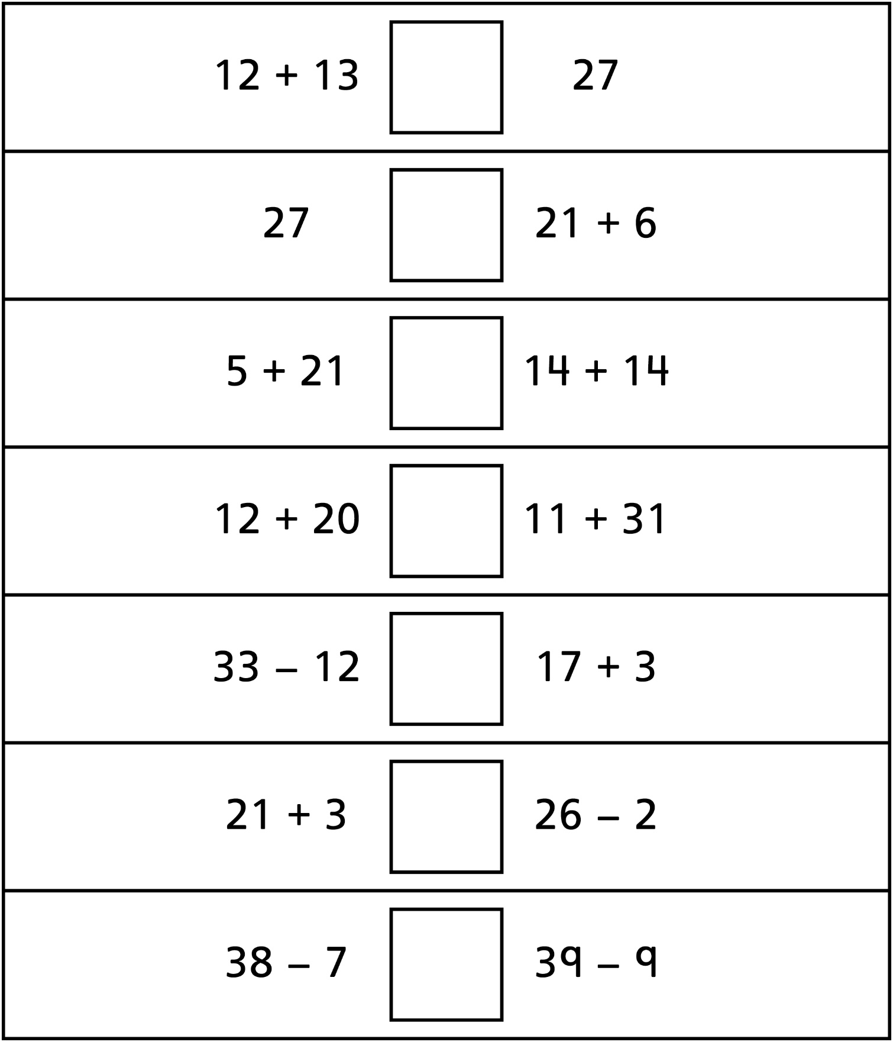
Write = or ≠ in each box.

