Adding and Subtracting Numbers to 20 Behaviours/Strategies
- Student counts to add and subtract with quantities to 20.  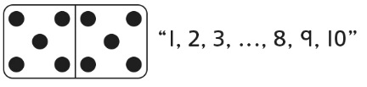 | - Student counts on or back to add  and subtract with quantities to 20.  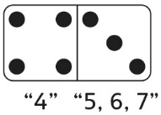 | - Student uses ten-frames and  counters or other materials to  show a strategy when adding and  subtracting with quantities to 20.  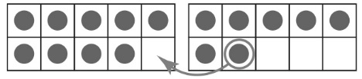 | 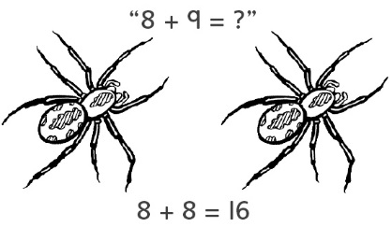  - Student refers to doubles pictures when extending known sums to add and subtract with quantities to 20.
Observations/Documentation
- Student uses the same strategy in every situation to add and subtract with quantities to 20.  “I like to use doubles!” | - Student fluently adds with  quantities to 20, but counts back  by 1s to subtract. | - Student adds and subtracts with  quantities to 20 and extends known sums to solve other equations, but struggles to explain thinking. | - Student fluently adds and subtracts with quantities to 20, extends known sums to solve other equations, and explains thinking.
Observations/Documentation

Big Idea |  |  |  |  | Indicators from Learning Progression
Curriculum Expectations addressed

Student Names
Student can find the complements of 10.
(Activity 32)
Student realizes that the order in which two numbers are added does not matter.
(Activity 32)
Student can use known doubles/sums/differences to find other sums/ differences.
(Activities 33, 34, 36)
Student can write number sentences to represent addition and subtraction situations.
(Activities 33, 34)
Student can fluently add and subtract numbers to 20.
(Activities 34, 36)
Student can use mental strategies to estimate sums and differences.
(Activity 35)
Student uses efficient
mental strategies to solve equations with multi-digit numbers.
(Activity 35)
Student uses math language to explain the strategies used to find answers.
(Activities 33, 34, 35, 36)

Name: _______________________

 | Not Observed | Sometimes | Consistently
Finds the complements of 10.
(Activity 32)
Realizes that the order in which two numbers are added does not matter.
(Activity 32)
Uses known doubles/sums/ differences to find other sums/differences.
(Activities 33, 34, 36)
Writes number sentences to represent addition and subtraction situations.
(Activities 33, 34)
Fluently adds and subtracts numbers to 20.
(Activities 34, 36)
Uses mental strategies to estimate sums and differences.
(Activity 35)
Uses efficient mental strategies to solve equations with multi-digit numbers.
(Activity 35)
Uses math language to explain the strategies used to find answers.
(Activities 33, 34, 35, 36)

Strengths:

Next Steps:

