**Question Cards**

**Master 95a**

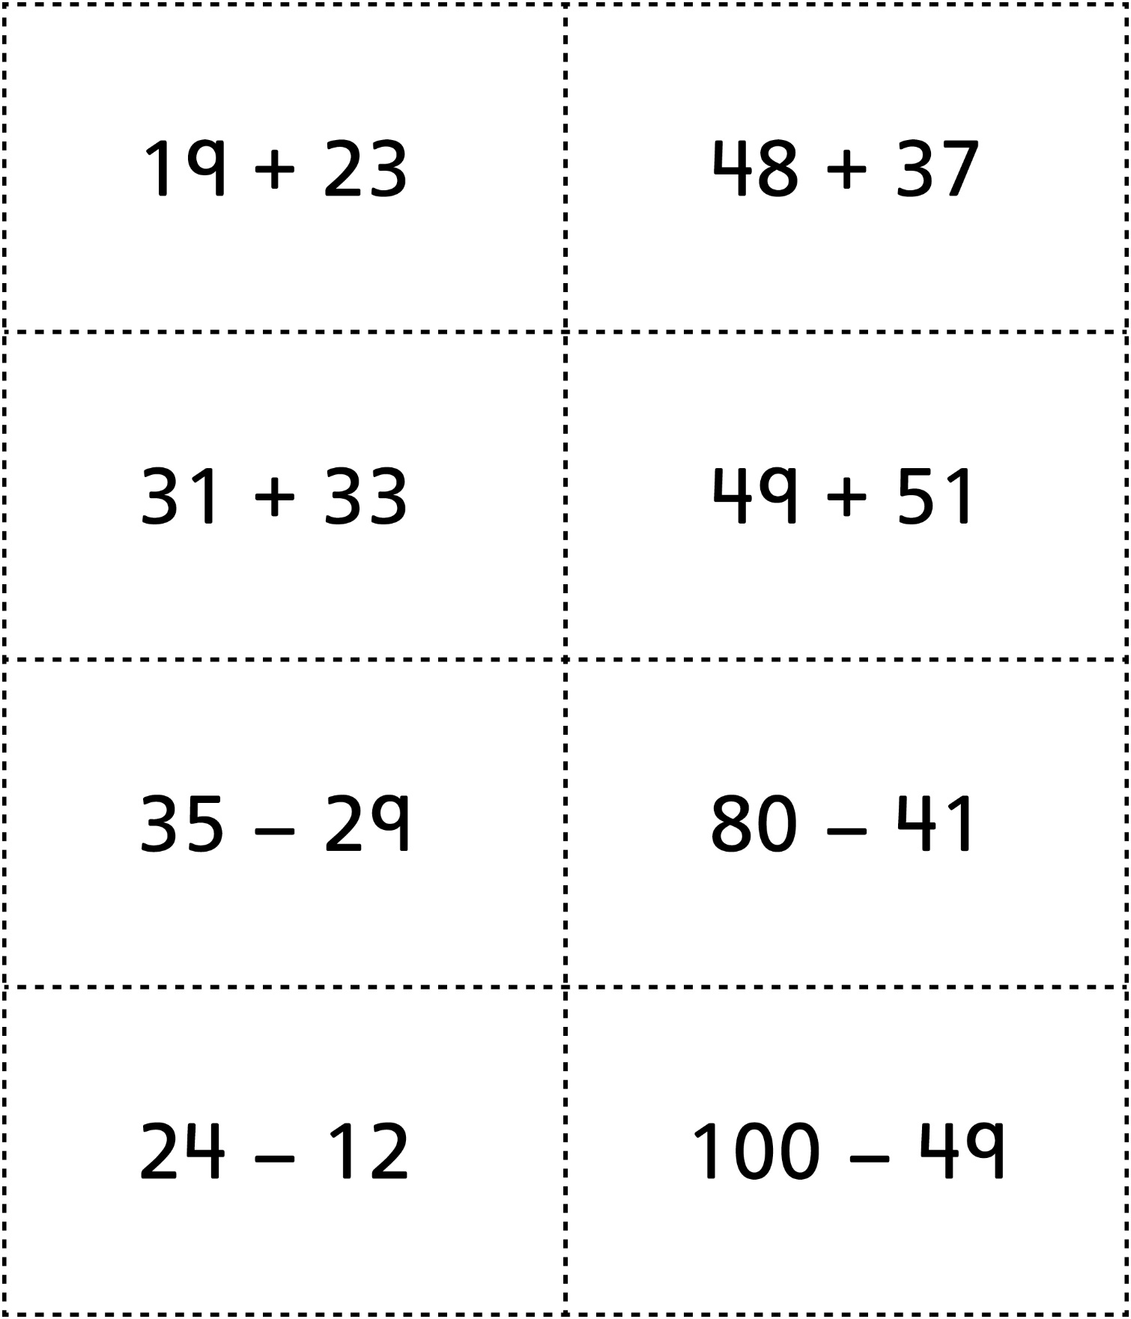

**Question Cards (for Accommodations)**

**Master 95b**

