**Seed Cards (0–20)**

**Master 86a**

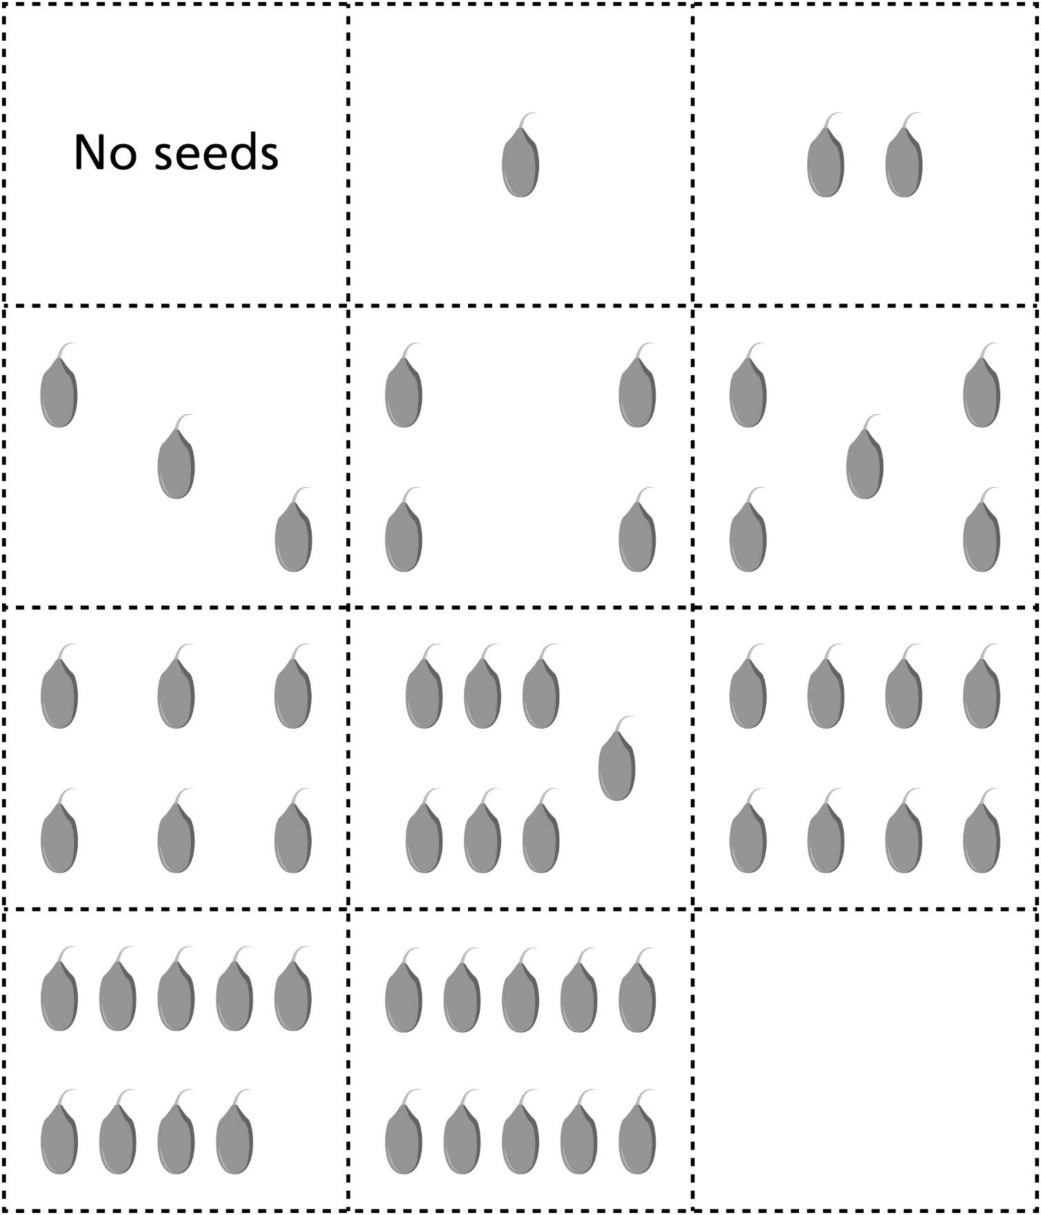

**Seed Cards (0–20)**

**Master 86b**

