Operational Sense Behaviours/Strategies
- Student turns over a domino, but is unable to use symbols and equations to represent an addition situation.  “I don’t know how to write an  addition sentence for a domino.” | - Student uses symbols and  equations to represent some  addition situations, but struggles  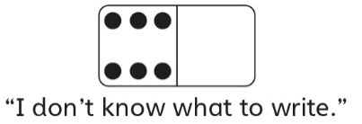  when one of the addends is zero. | - Student uses symbols and  equations to represent an addition situation in one way, but does not use the commutative property to represent it another way.  “3 + 4 = 7. I don’t know  another sentence.” | - Student successfully uses symbols and equations to represent addition and subtraction situations and  shows understanding of the zero  and commutative properties.  7 + 0 = 7  0 + 7 = 7  7 – 0 = 7
Observations/Documentation
Mental Math and Computational Behaviours/Strategies
- Student counts three times to add quantities (find the total number of dots).  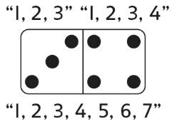 | - Student counts on from the  smaller number to add quantities.  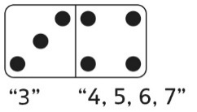 | 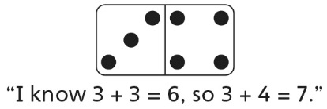  - Student uses a known fact, doubles, or skip-counting to add quantities. | - Student fluently adds and subtracts with quantities to 10.  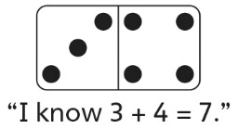
Observations/Documentation

