Number Relationships Behaviours/Strategies
- To decompose two-digit numbers  into parts, student counts out  counters and then arranges them  in two groups. | - To decompose two-digit numbers  into parts, student chooses a part  and then counts on or back with  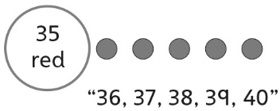  counters to find the other part. | - Student decomposes two-digit  numbers into parts, but struggles  to compose two-digit numbers  from parts (unable to take jumps  of different sizes on a number line). | 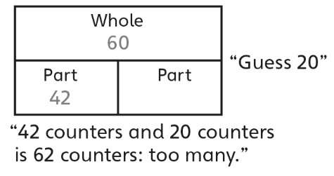  - To find a part given the whole and another part, student guesses and then uses counters to check.
Observations/Documentation
- To find a part given the whole and another part, student counts on or back with counters or fingers.  “43, 44, 45, ..., 58, 59, 60” | - Student shows benchmark  numbers on the number line, but  struggles to name a number closer to the given ten.  “36 is between 30 and 40, but I don’t know which number it is closer to.” | - Student shows benchmark numbers on the number line, but struggles to name the number that is the same distance from both benchmarks.  “I don’t know what number is the  same distance from 80 as  from 90.” | - Student successfully demonstrates an understanding of number relationships by using efficient strategies (skip-counting, mental math) to answer cards of all types.
Observations/Documentation

Big Idea |  |  |  |  | Indicators from Learning Progression
Curriculum Expectations addressed

Student Names
Student can compare numbers using benchmarks on a number line.
(Activities 22, 25)
Student can name the ten closer to a number.
(Activities 22, 25)
Student can name the number that is the same distance from both benchmark numbers.
(Activities 22, 25)
Student can decompose two-digit numbers into two parts in different ways.
(Activities 23, 25)
Student recognizes that no matter how objects are partitioned, the total does not change (conservation).
(Activities 23)
Student can find a part given the whole and another part.
(Activities 23, 25)
Student can decompose numbers in different ways on a number line.
(Activities 24, 25)

Name: _______________________

 | Not Observed | Sometimes | Consistently
Compares numbers using benchmarks on a number line.
(Activities 22, 25)
Names the ten closer to a number.
(Activities 22, 25)
Names the number that is the same distance from both benchmark numbers.
(Activities 22, 25)
Decomposes two-digit numbers into two parts in different ways.
(Activities 23, 25)
Recognizes that no matter how objects are partitioned, the total does not change (conservation).
(Activities 23)
Finds a part given the whole and another part.
(Activities 23, 25)
Decomposes numbers in different ways on a number line.
(Activities 24, 25)

Strengths:

Next Steps:

