Decomposing Numbers Behaviours/Strategies
- Student decomposes number into units of tens and leftover ones, but has more than 10 cubes in the Ones column or confuses the number of tens with the number of cubes.  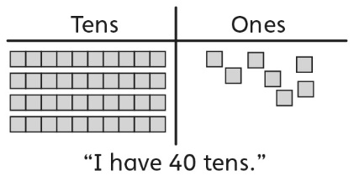 | - Student decomposes number into units of tens and leftover ones, and uses cubes to determine how many more ones are needed to make another ten.  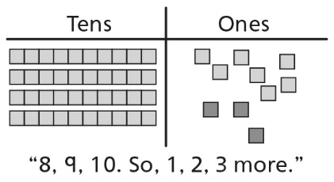 | - Student decomposes number into units of tens and leftover ones, but is unable to determine 10 more/less without counting. | - Student decomposes number into units of tens and leftover ones, determines how many more ones are needed to make another ten, and finds 10 more/less without counting.  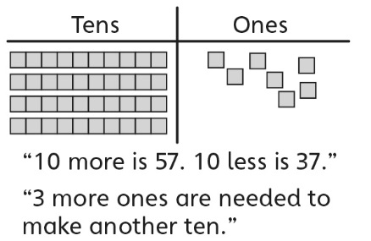
Observations/Documentation
Partitioning into Equal-Sized Units Behaviours/Strategies
- Student counts objects by 1s, but  struggles to partition objects into  equal-sized units (not all units are equal).  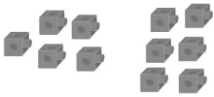 | - Student partitions into and skip-counts by equal-sized units, but  continues to skip-count to count  the leftovers.  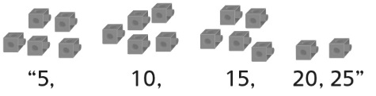 | - Student partitions into and skip-counts by equal-sized units, but  does not recognize relationships  among the different unit sizes. | - Student successfully partitions into and skip-counts by equal-sized units and recognizes relationships among the different unit sizes.
Observations/Documentation

Big Idea |  |  |  |  | Indicators from Learning Progression
Curriculum Expectations addressed

Student Names
Student can compose and decompose two-digit numbers into units of tens and leftover ones.
(Activities 13, 16)
Student can relate the number of tens and leftover ones to the digits of a number.
(Activities 13, 16)
Student can determine how many more ones are needed to make another ten.
(Activities 13, 16)
Student can determine 10 more or less than a number without counting.
(Activities 14, 16)
Student can partition objects into equal-sized groups to count them in different ways.
(Activities 15, 16)
Student recognizes that no matter how objects are grouped, the total does not change (conservation).
(Activity 15, 16)
Student realizes that, as the number of objects in a group increases, the number of groups decreases.
(Activities 15, 16)

Name: _______________________

 | Not Observed | Sometimes | Consistently
Composes and decomposes two-digit numbers into units of tens and leftover ones.
(Activities 13, 16)
Relates the number of tens and leftover ones to the digits of a number.
(Activities 13, 16)
Determines how many more ones are needed to make another ten.
(Activities 13, 16)
Determines 10 more or less than a number without counting.
(Activities 14, 16)
Partitions objects into equal-sized groups to count them in different ways.
(Activities 15, 16)
Recognizes that no matter how objects are grouped, the total does not change (conservation).
(Activity 15, 16)
Realizes that, as the number of objects in a group increases, the number of groups decreases.
(Activities 15, 16)

Strengths:

Next Steps:

