Ordinal Word Cards (to twentieth)
Master 24a

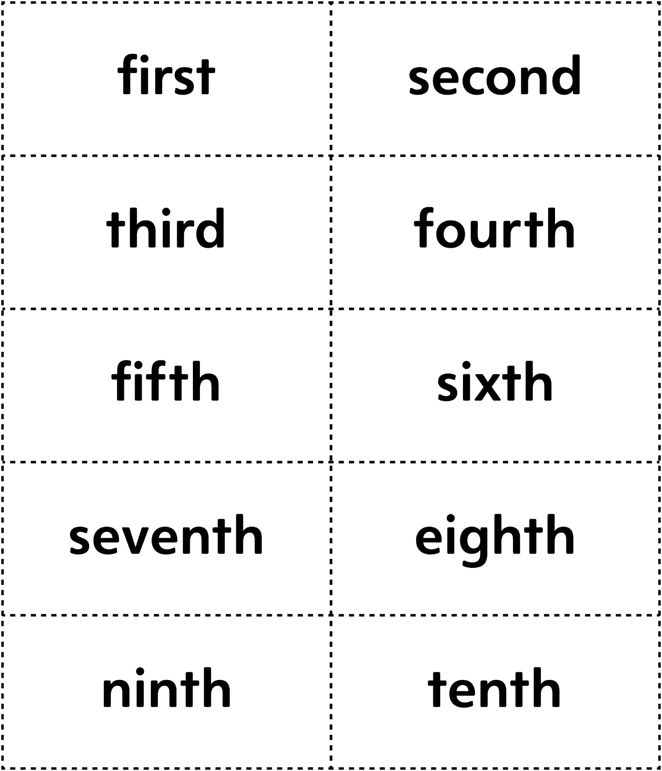

Ordinal Word Cards (to twentieth)
Master 24b

