Counting On and Back Behaviours/Strategies
- Student uses correct start number, but omits numbers or mixes up the order when saying the number name sequences forward and backward.  “11, 12, 14, 16, 17” | - Student says the number name  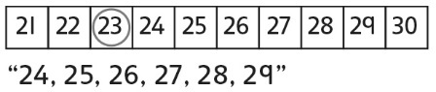  sequences forward and backward from a given number, but relies on the hundred chart. | - Student says the number name  sequences forward and backward from a given number, but struggles to bridge tens.  “Eight, nine, ten, ten-one, ten-two” | - Student says the number name  sequences forward and backward from a given number and uses number patterns to bridge tens.
Observations/Documentation
Skip-Counting Forward and Backward Behaviours/Strategies
- Student uses correct start number, but mixes up the numbers or omits numbers when skip-counting forward and backward by factors of 10.  “5, 10, 20, 25, 35” | - Student skip-counts forward by  factors of 10, but struggles to skip-count backward.  “It is much easier to skip-count  forward.” | - Student skip-counts forward and  backward by factors of 10, but uses fingers or the hundred chart to help.  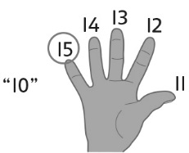 | - Student fluently skip-counts forward and backward by factors of 10.  “80, 70, 60, 50, 40”  “60, 65, 70, 75, 80, 85”  “50, 48, 46, 44, 42, 40”
Observations/Documentation

Big Idea |  |  |  |  | Indicators from Learning Progression
Curriculum Expectations addressed

Student Names
Student can count on and back by 1s from a given number.
(Activities 1, 5)
Student can use number patterns to bridge tens when counting on and back by 1s.
(Activities 1, 5)
Student can skip-count forward by 2s, 5s, and 10s.
(Activities 2, 5)
Student can skip-count forward by 2s and 10s from any given number.
(Activity 3)
Student can skip-count backward by 2s, 5s, and 10s.
(Activities 4, 5)
Student can identify patterns in the skip-counting sequences.
(Activities 2, 3, 4, 5)
Student can identify errors or missing numbers in a skip-counting sequence. (Activity 2, 3, 4, 5)

Name: _______________________

 | Not Observed | Sometimes | Consistently
Counts on and back by 1s from a given number.
(Activities 1, 5)
Uses number patterns to bridge tens when counting on and back by 1s.
(Activities 1, 5)
Skip-counts forward by 2s, 5s, and 10s.
(Activities 2, 5)
Skip-counts forward by 2s and 10s from any given number.
(Activity 3)
Skip-counts backward by 2s, 5s, and 10s.
(Activities 4, 5)
Identifies patterns in the skip-counting sequences.
(Activities 2, 3, 4, 5)
Identifies errors or missing numbers in a skip-counting sequence.
(Activities 2, 3, 4, 5)

Strengths:

Next Steps:

