Calendar
Master 124

Month __________________ My savings goal: ____________¢

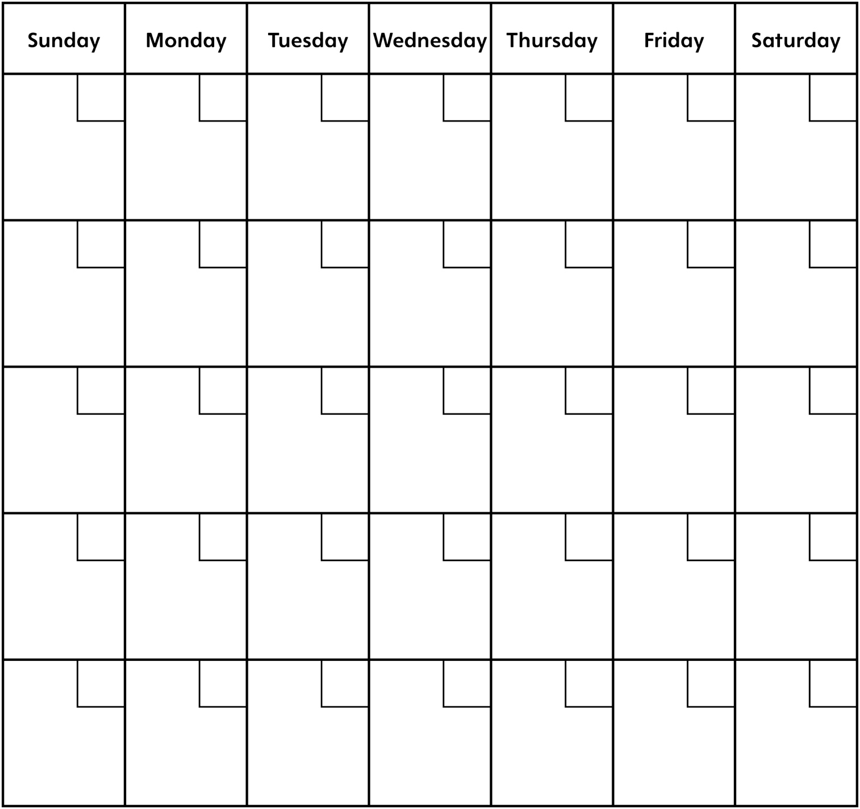
How much was saved? _________¢

Was the goal met? Circle the answer. YES NO

If the answer is NO, how much more money needs to be earned? _________¢

