How Many? Objects
Master 107

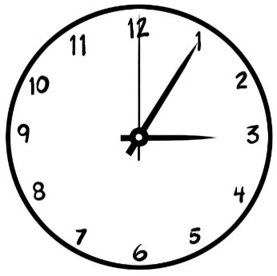

1 clock has 3 hands.

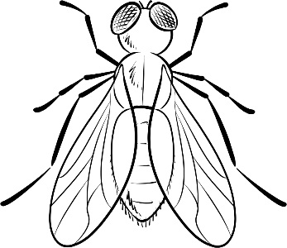

1 insect has 6 legs.

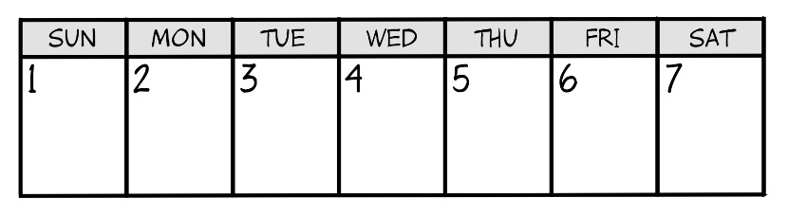

1 week has 7 days.

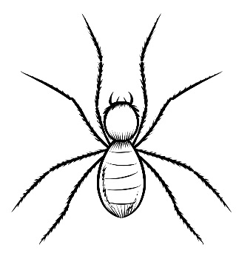

1 spider has 8 legs.

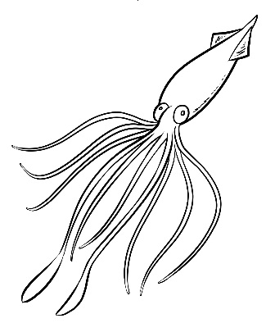

1 squid has 10 limbs.

