Skip-Counting by 10s Spider Webs
Master 7a

Start at 0. Skip-count by 10s.

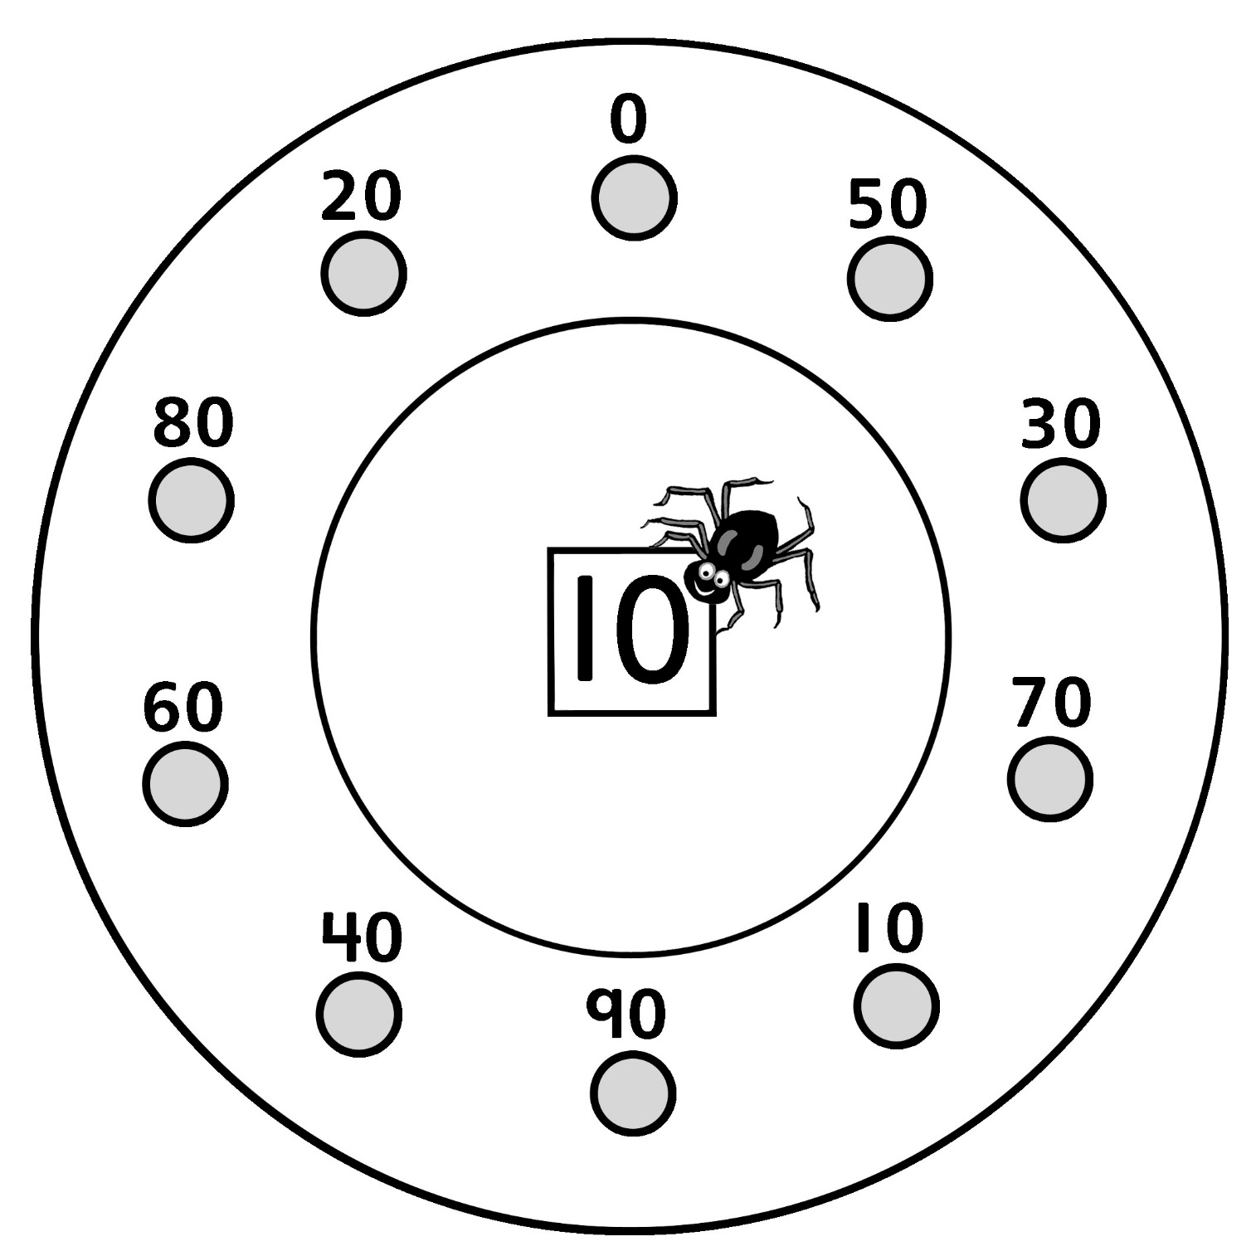

Skip-Counting by 10s Spider Webs
Master 7b

Start at 10. Skip-count by 10s.

