**Month Clue Cards**

**Master 37a**

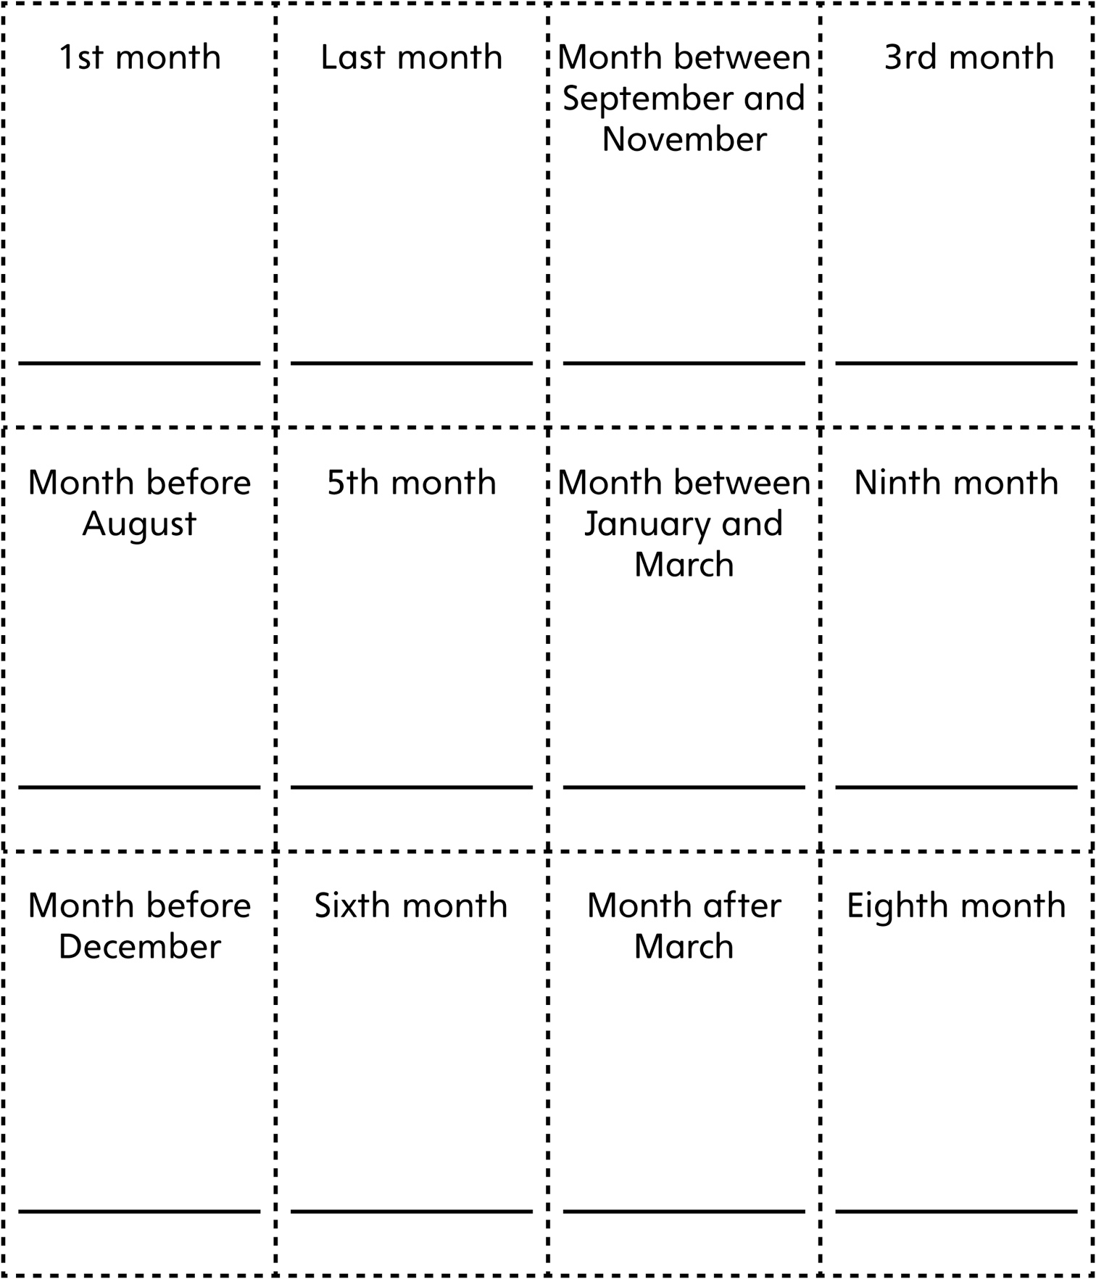

**Month Clue Cards   
(for Accommodations)**

**Master 37b**

