Metres or Centimetres?
Master 27a

Length of Pen  We will use  centimetres or metres  We will use  ruler or metre stick  Our measure is  ____________________________ | 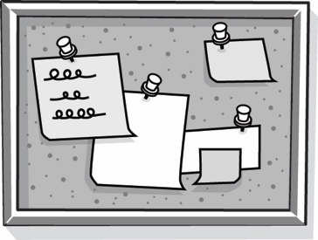  Length of Bulletin Board  We will use  centimetres or metres  We will use  ruler or metre stick  Our measure is  ____________________________
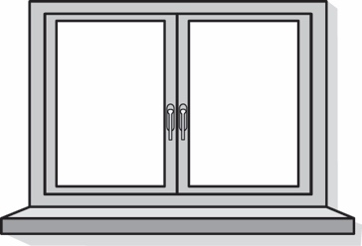  Length of Window Ledge  We will use  centimetres or metres  We will use  ruler or metre stick  Our measure is  ____________________________ | Glue Stick  We will use  centimetres or metres  We will use  ruler or metre stick  Our measure is  ____________________________

Metres or Centimetres?
Master 27b

(for Extension)
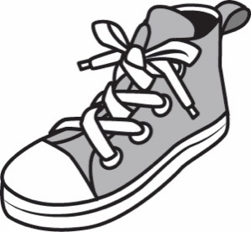  Length of Your Shoe  We will use  centimetres or metres  We will use  ruler or metre stick  Our measure is  ____________________________ | 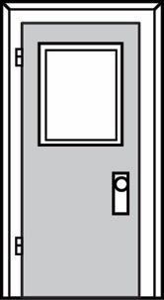  Height of Classroom Door  We will use  centimetres or metres  We will use  ruler or metre stick  Our measure is  ____________________________
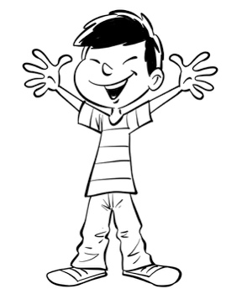  Height of a Classmate  We will use  centimetres or metres  We will use  ruler or metre stick  Our measure is  ____________________________ | 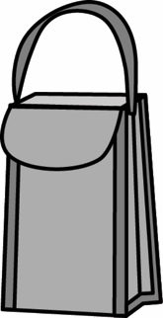  Height of Lunch Bag  We will use  centimetres or metres  We will use  ruler or metre stick  Our measure is  ____________________________

