How Many Centimetres?
Master 24a

Whiteboard Eraser  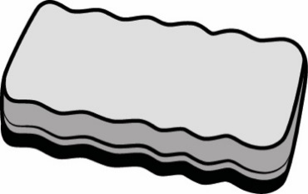  Our estimate is  ____________________________  Our measure is  ____________________________ | Marker  Our estimate is  ____________________________  Our measure is  ____________________________
Eraser  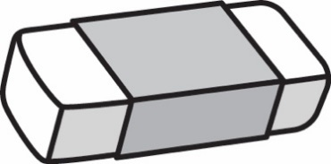  Our estimate is  ____________________________  Our measure is  ____________________________ | Large Paper Clip  Our estimate is  ____________________________  Our measure is  ____________________________

How Many Centimetres?
Master 24b

Small Scissors  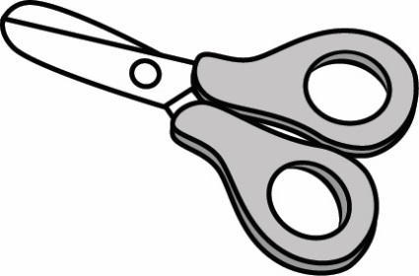  Our estimate is  ____________________________  Our measure is  ____________________________ | Length of Book  Our estimate is  ____________________________  Our measure is  ____________________________
Length of Crayon  Our estimate is  ____________________________  Our measure is  ____________________________ | Length of Paint Brush  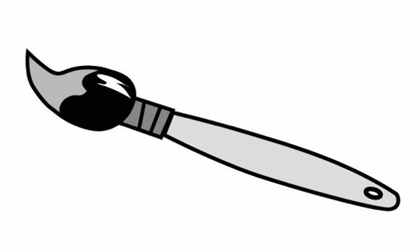  Our estimate is  ____________________________  Our measure is  ____________________________

