Using Repeated Addition and Subtraction Behaviours/Strategies
- Student counts all items by 1s and does not  recognize number patterns in repeated units.  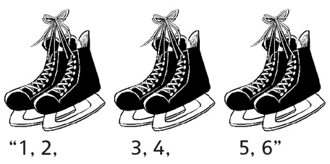 | - Student counts on or back to count items and  does not recognize number patterns in repeated units.  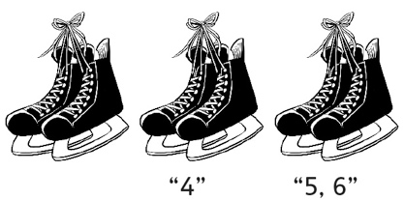 | - Student recognizes number patterns in  repeated units and skip-counts forward or  backward to find how many.  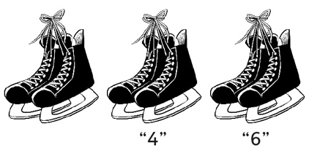
Observations/Documentation
- Student recognizes number patterns in  repeated units and uses addition or subtraction to find how many, but does not see relation to repeated addition or subtraction. | - Student recognizes number patterns in  repeated units and uses repeated addition or  subtraction of groups to solve problems, but  is unable to use math language to explain  thinking. | - Student recognizes number patterns in  repeated units and uses repeated addition or  subtraction of groups to solve problems.
Observations/Documentation

