Identifying and Sorting Coins Behaviours/Strategies
- Student looks at coins, but is  unable to sort them using a single attribute. | - Student sorts a set of objects (coins) using a single attribute, but puts coins in wrong jars.  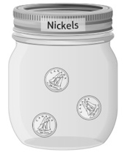 | - Student sorts a set of objects  (coins) using a single attribute, but does not remember the values of the coins.  “I don’t remember how much  a nickel is worth.” | - Student successfully sorts a set  of objects (coins) using a single  attribute and associates each coin with a value.
Observations/Documentation
Determining the Value of a Collection of Coins Behaviours/Strategies
- Student sorts coins, but is unable  to find value of coins as he or she does not associate value of coin with a skip-counting number.  “A dime is 10 cents. What number do I skip-count by?” | - Student sorts coins, but is unable to skip-count by factors of 10 or 100.  “10, 20, 30, 50, 60” | - Student skip-counts by factors of  10, but struggles to skip-count by  factors of 100 (e.g., 25).  “25, ?” | - Student successfully skip-counts by factors of 10 and 100.
Observations/Documentation

