Adding to Determine Doubles to 10 Behaviours/Strategies
- Student counts three times to determine  doubles when adding with quantities to 20.  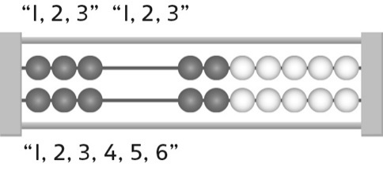 | - Student counts on to determine doubles when  adding with quantities to 20.  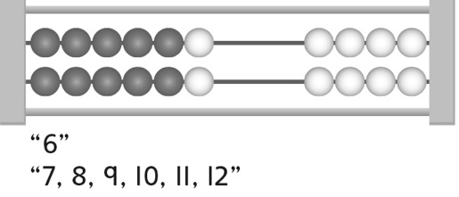 | - Student makes 10 and counts all to determine  doubles when adding with quantities to 20.  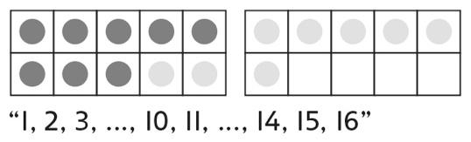
Observations/Documentation
- Student makes 10 and counts on to determine  doubles when adding with quantities to 20.  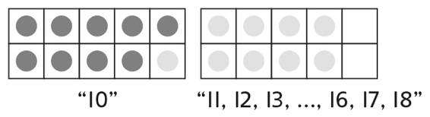 | - Student fluently adds with quantities to 20 to  determine doubles, but struggles to write the  addition sentence.  “I don’t know what to write.” | - Student fluently adds with quantities to 20  to determine doubles and writes addition  sentences.
Observations/Documentation

