Composing Quantities from Parts Behaviours/Strategies
- Student counts three times to  compose quantities from parts.  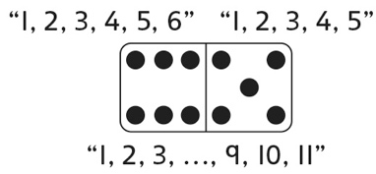 | - Student skip-counts by 2s to  compose quantities from parts.  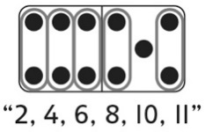 | - Student instantly recognizes one  of the parts (perceptual subitizing), and then counts on to compose quantities from parts.  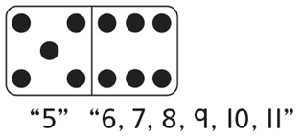 | - Student uses number relationships to compose quantities from parts.  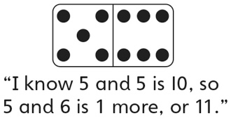
Observations/Documentation
Decomposing the Whole Behaviours/Strategies
- Student chooses randomly to find dominoes with parts that make the same whole.  “Let’s try this one.” | - Student finds dominoes with parts that make the same whole when the whole is small, but struggles when the whole is large.  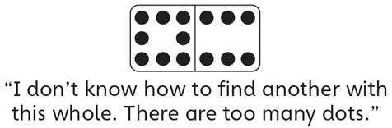 | - Student finds all dominoes with parts that make the same whole, but does not see patterns in the parts.  “I sorted them, but I don’t see  any patterns.” | - Student uses patterns to  systematically find all dominoes with parts that make the same whole.
Observations/Documentation

