Skip-Counting with Objects Behaviours/Strategies
- Student successfully counts by 1s, but struggles to partition into and skip-count by equal-sized units as he or she does not associate the skip-counting number with a quantity.  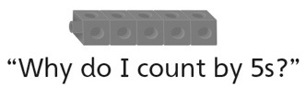 | - Student partitions into and skip-counts by  equal-sized units to 10, but struggles to know  which number comes next.  “2, 4, 6, 8, 10, ?” | - Student partitions into and skip-counts by  equal-sized units, but mixes up the numbers in  the skip-counting sequence.  “10, 20, 40, 30, 50”
Observations/Documentation
- Student partitions into and skip-counts by equal-sized units, but does not recognize that  the last counting number tells how many.  “10, 20, 30, 40, 50  I’m not sure how many there are.” | - Student partitions into and skip-counts by  equal-sized units, but does not recognize that  the results will be the same no matter how the  objects are counted.  “There were 50 when I counted by 2s.  I’m not sure how many there will be when  I count by 5s.” | - Student partitions into and skip-counts by  equal-sized units and recognizes that the results will be the same no matter how the objects are counted.
Observations/Documentation

