Telling Time to the Hour and Half-Hour Behaviours/Strategies
- Student explores measurement of non-visible  attributes (time), but does not realize that each number on the analogue clock represents 5 minutes. | - Student explores measurement of non-visible  attributes (time), but struggles to skip-count by 5s.  “5, 10, 20, 30” | - Student explores measurement of non-visible  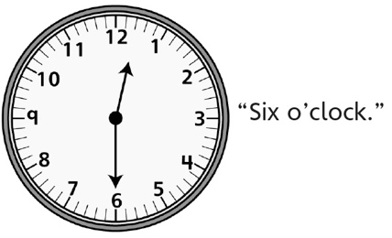  attributes (time), but mixes up the hour and  minute hands on the analogue clock.
Observations/Documentation
- Student explores measurement of non-visible  attributes (time), but struggles to read time on  a digital clock.  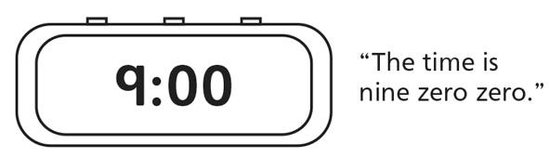 | - Student explores measurement of non-visible  attributes (time), but struggles to explain  thinking. | - Student successfully explores measurement of  non-visible attributes (time) and reads time to  the hour and half-hour on analogue and digital  clocks.
Observations/Documentation

