What Time Is It? Game Board
Intervention: Master 62a

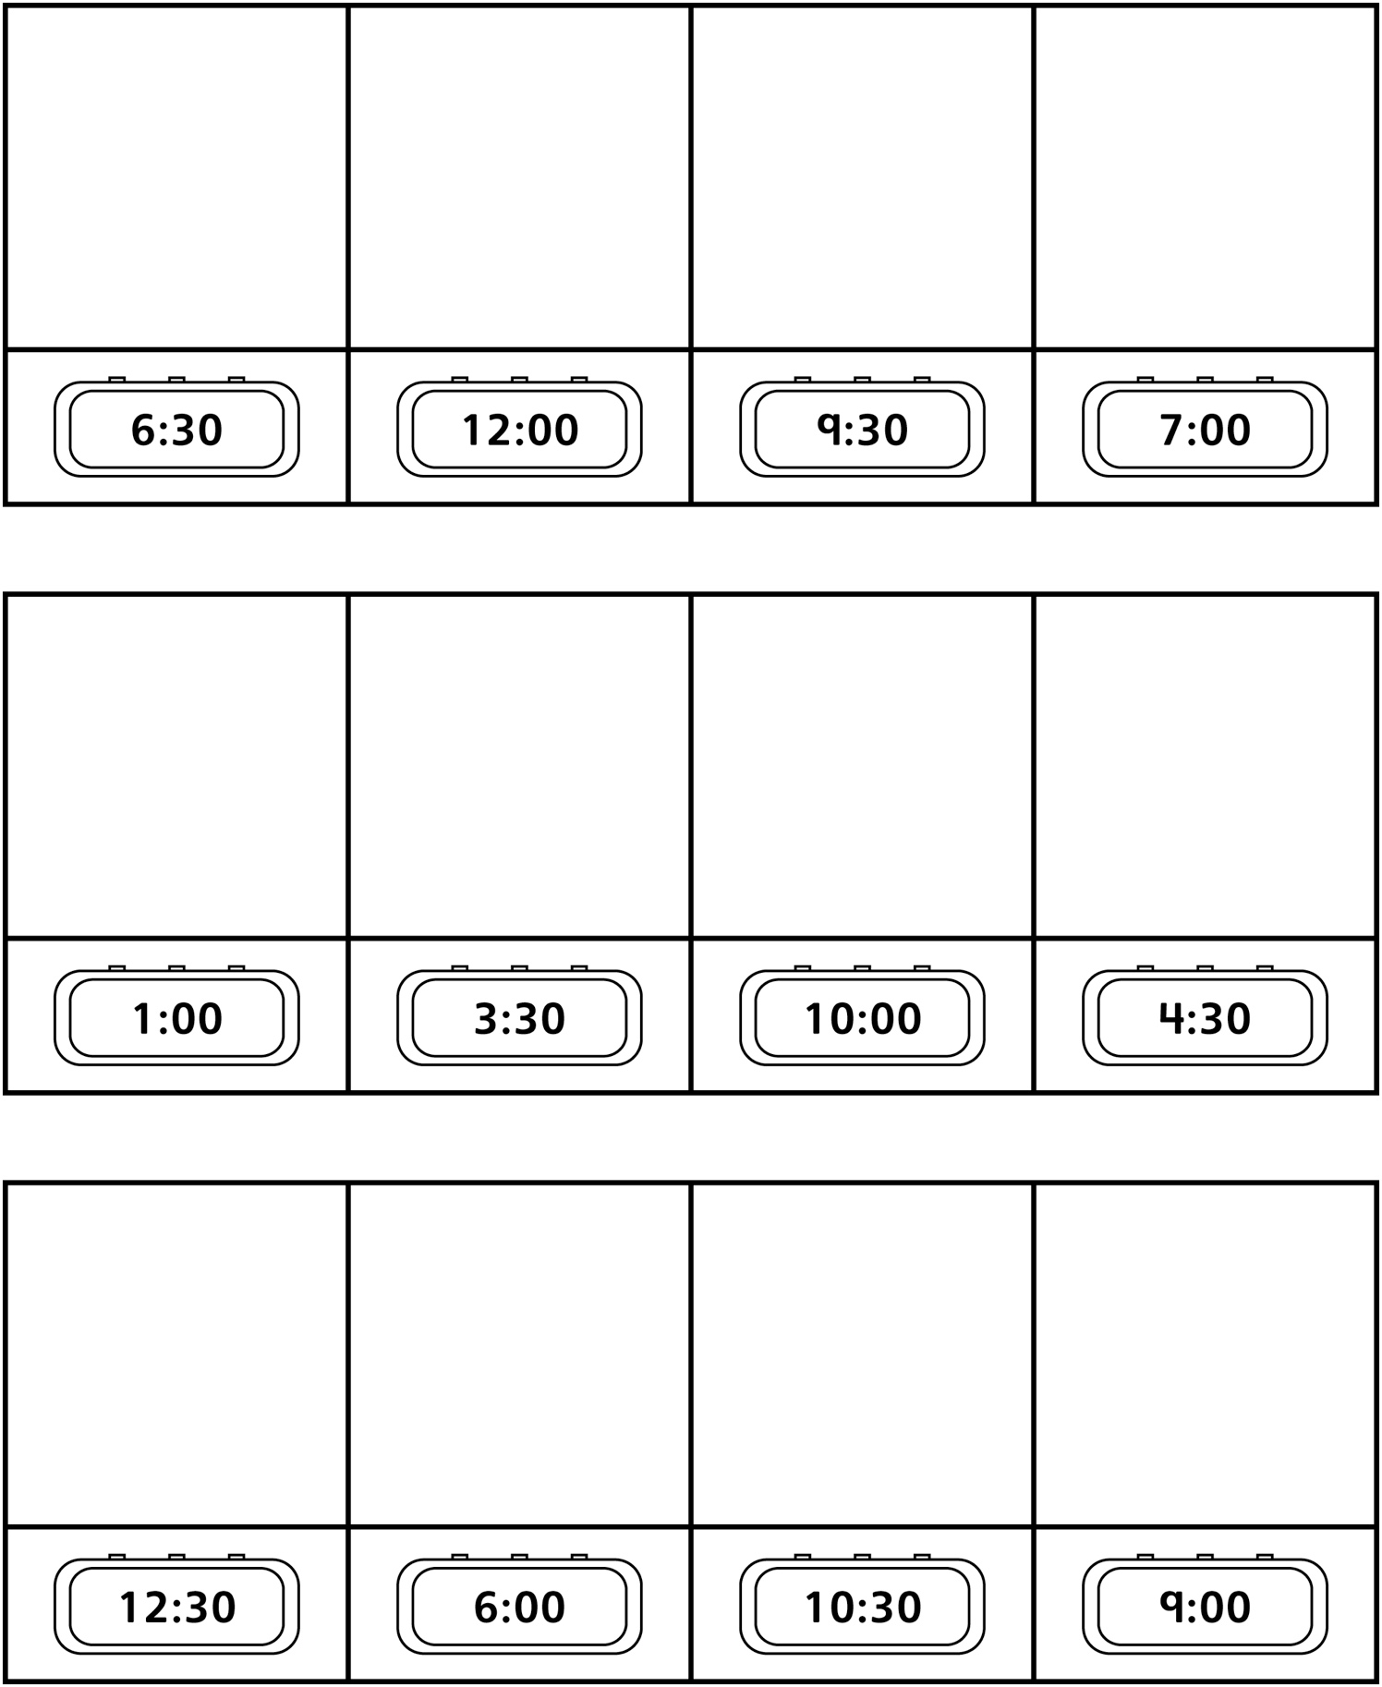
What Time Is It? Game Board
Intervention: Master 62b

(for Accommodations)

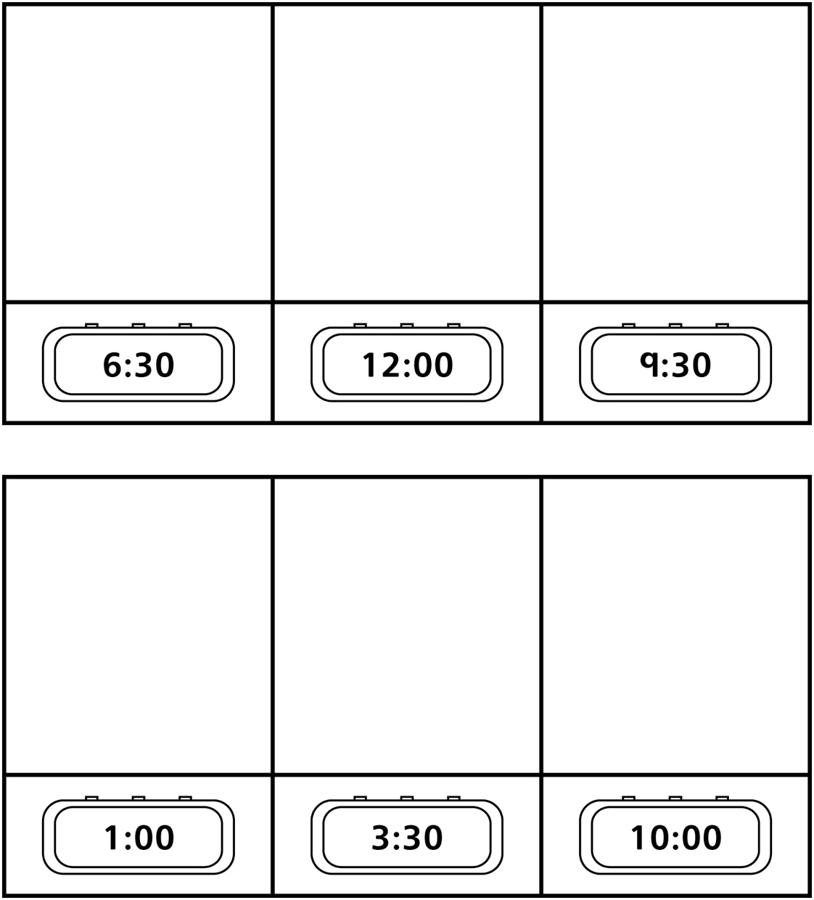
What Time Is It? Game Board
Intervention: Master 62c

(for Extension)

