Ordering Months of the Year Behaviours/Strategies
- Student understands the  attributes of a calendar (months in  a year), but cannot say the months  in order. | - Student understands the  attributes of a calendar (months  in a year) and says the months in  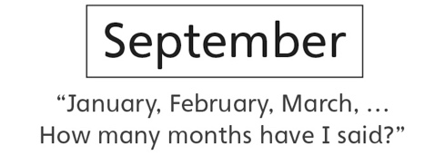  order, but loses track of the count. | - Student understands the  attributes of a calendar (months in  a year) and orders the months, but  is unable to name things he or she  might do in a particular month.  “I don’t know what I do in June.” | - Student understands the  attributes of a calendar (months  in a year), successfully orders the  months, and associates months  with events/activities.
Observations/Documentation

