Conserving Area Behaviours/Strategies
- Student explores area, but struggles to match  sides of squares exactly. | - Student explores area, but believes more than  4 new shapes are possible.  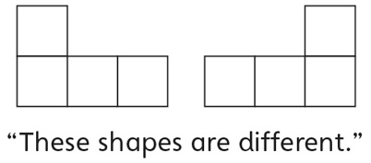 | - Student measures shapes by area using multiple copies of a non-standard unit, but randomly covers the shapes with tiles (has gaps or overlaps).  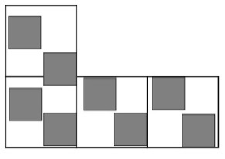
Observations/Documentation
- Student measures shapes by area using multiple copies of a non-standard unit, but struggles to describe area. | - Student measures shapes by area using  multiple copies of a non-standard unit, but  thinks two shapes that look different cannot  have the same area.  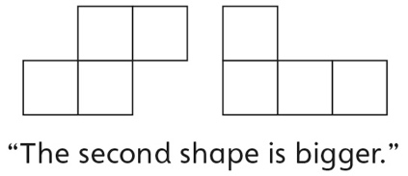 | - Student successfully measures and describes  shapes by area with non-standard units and  understands that shapes that look different can  have the same area (conservation).
Observations/Documentation

