Measuring Length with Non-Standard Units Behaviours/Strategies
- Student measures objects by length using  multiple copies of a non-standard unit, but ruler has big gaps or overlaps.  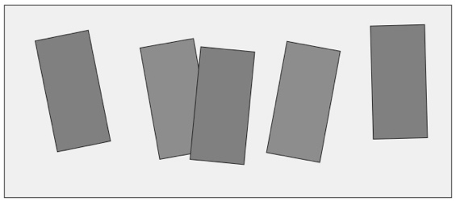 | - Student measures objects by length using  multiple copies of a non-standard unit, but ruler has some gaps or overlaps.  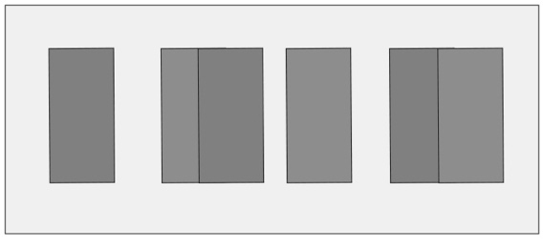 | - Student measures objects by length using  multiple copies of a non-standard unit, but does  not align the base of the first unit with the end  of the object being measured.  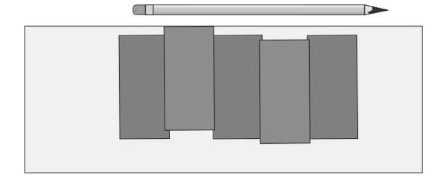
Observations/Documentation
- Student measures objects by length using  multiple copies of a non-standard unit, but loses count when measuring. | - Student measures objects by length using  multiple copies of a non-standard unit, but  forgets to include the unit when stating the  measures.  “It is 6 long.” | - Student successfully measures objects by length using multiple copies of a non-standard unit and includes the unit in measures.
Observations/Documentation

