**Fill Me!**

**Intervention: Master 75a**

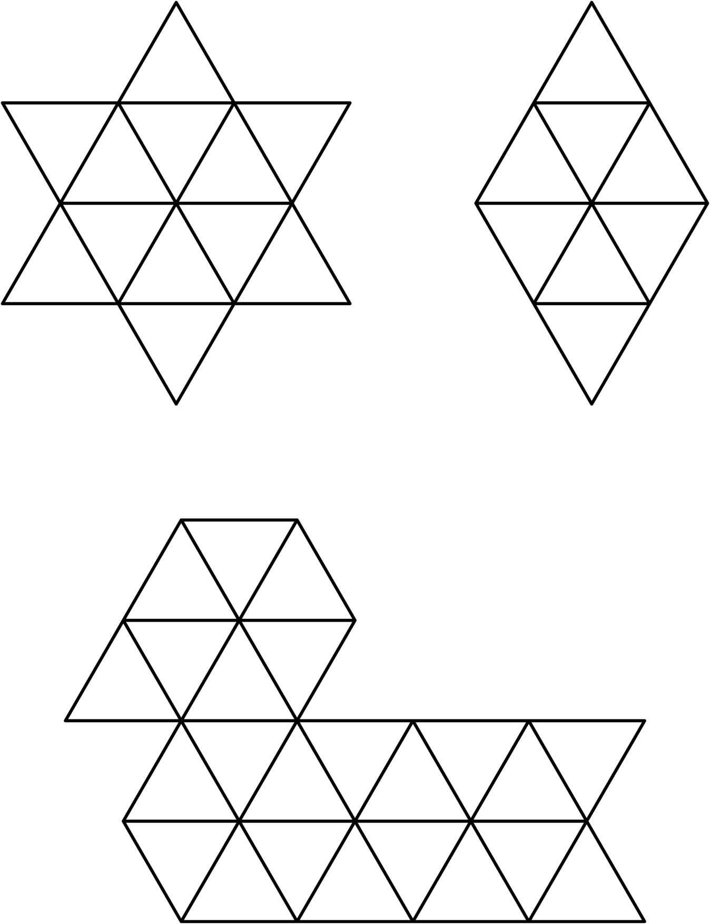

**Fill Me!**

**Intervention: Master 75b**

**(for Accommodations)**

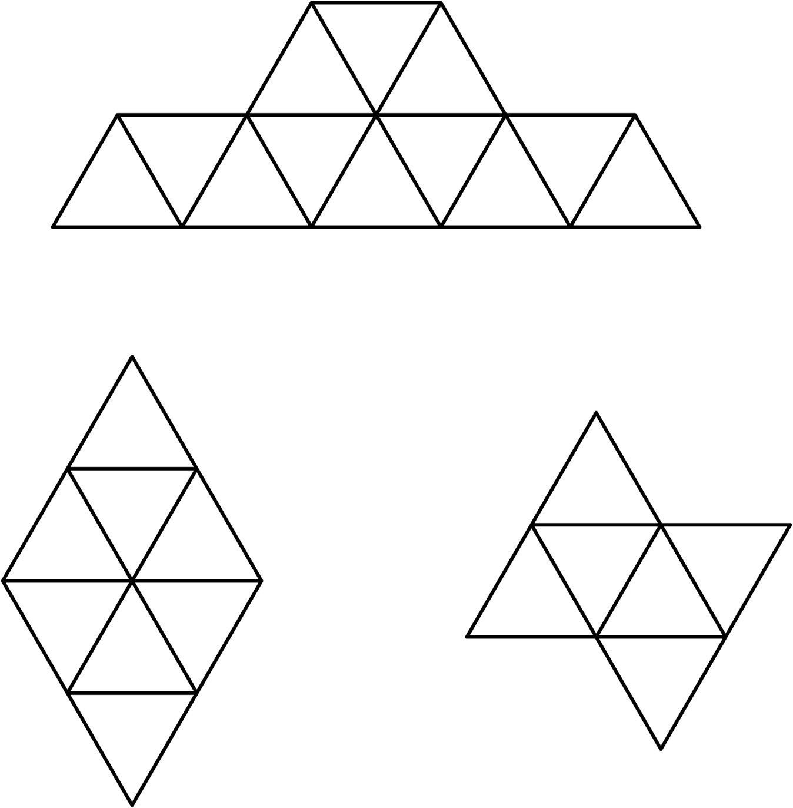

**Fill Me!**

**Intervention: Master 75c**

**(for Extension)**

