Analyzing and Identifying 3-D Solids Behaviours/Strategies
- Student struggles to analyze attributes of 3-D  solids and answers questions randomly. | - Student struggles to identify 3-D solids and  guesses (ignores answers to questions). | - Student attempts to identify 3-D solids, but uses  non-math language when asking questions.  “Does it have points?  Does it look like a ball?”
Observations/Documentation
- Student attempts to identify 3-D solids, but  asks questions in a random order and does not appear to have a strategy.  “Does the solid have vertices?” No  “Does the solid have edges?” No  “Does the solid have faces?” No | - Student recognizes 3-D solids, but cannot name some of them.  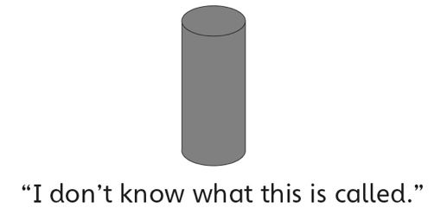 | - Student successfully analyzes attributes of 3-D  solids, identifies 3-D solids, and names them.  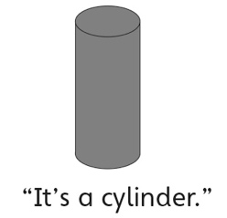
Observations/Documentation

