Geometric Relationship Tasks Behaviours/Strategies
- Student uses blocks or pieces, but  struggles to construct new  2-D shapes as a composite of other 2-D shapes. | 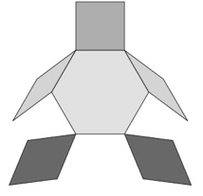  - Student constructs a composite  picture with 2-D shapes, but each  shape represents a part of an object (shapes are not combined). | - Student covers a picture outline with shapes, but picture has gaps or overlaps.  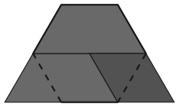 | - Student covers a picture outline  with shapes, but always tries to  place matching blocks in the same relative position.  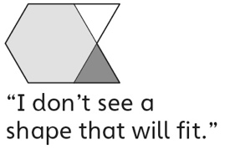
Observations/Documentation
- Student constructs a new 2-D shape as a composite of other shapes and covers outlines, but thinks only one way is possible. | - Student constructs a 2-D design, but places blocks/pieces randomly and creates an unsymmetrical design.  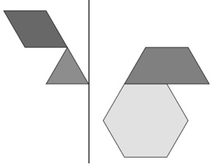 | - Student creates shape/solid, but focuses on only part of the description and creates an incorrect shape/solid. | - Student successfully constructs  2-D shapes and solids, composite  pictures, and symmetrical designs, and covers outlines in more than one way.

Big Idea |  |  |  |  | Indicators from Learning Progression
Curriculum Expectations addressed

Student Names
Student can construct 2-D shapes from other shapes.
(Activities 11, 17)
Student can construct a composite structure with 3-D solids.
(Activities 12, 17)
Student can name familiar 2-D shapes and 3-D solids.
(Activities 11, 12, 13, 14, 15, 16, 17)
Student can identify the shapes of the faces of 3-D solids.
(Activities 12, 13, 17)
Student can create shapes and solids from given attributes.
(Activities 13, 17)
Student uses math language to describe the attributes of shapes and solids.
(Activities 11, 12, 13, 14, 15, 16, 17)
Student can construct pictures and designs with 2-D shapes.
(Activities 14, 17)
Student can cover an outline with 2-D shapes in more than one way.
(Activities 15, 17)
Student can construct and describe 2-D symmetrical designs.
(Activities 16, 17)

Name: _______________________

 | Not Observed | Sometimes | Consistently
Constructs 2-D shapes from other shapes.
(Activities 11, 17)
Constructs a composite structure with 3-D solids.
(Activities 12, 17)
Names familiar 2-D shapes and 3-D solids.
(Activities 11, 12, 13, 14, 15, 16, 17)
Identifies the shapes of the faces of 3-D solids.
(Activities 12, 13, 17)
Creates shapes and solids from given attributes.
(Activities 13, 17)
Uses math language to describe the attributes of shapes and solids.
(Activities 11, 12, 13, 14, 15, 16, 17)
Constructs pictures and designs with 2-D shapes.
(Activities 14, 17)
Covers an outline with 2-D shapes in more than one way.
(Activities 15, 17)
Constructs and describes
2-D symmetrical designs.
(Activities 16, 17)

Strengths:

Next Steps:

