Describing Attributes of Shapes and Solids Behaviours/Strategies
- Student chooses a shape/solid,  but has difficulty analyzing it and  describing its attributes. | - Student analyzes geometric  attributes of a shape/solid, but uses non-math language to describe it.  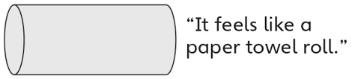 | - Student analyzes geometric  attributes of a shape/solid, but  gives a general description.  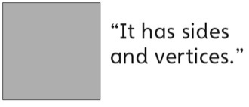 | - Student successfully analyzes  geometric attributes of 2-D shapes and 3-D solids and uses math language to describe them.
Observations/Documentation
Visualizing and Creating Shapes and Solids Behaviours/Strategies
- Student creates a shape/solid,  but guesses and ignores partner’s description. | - Student creates a shape/solid,  but focuses on only part of the  description and creates incorrect  shape/solid. | - Student creates shapes and solids from description and visualization, but struggles to identify them.  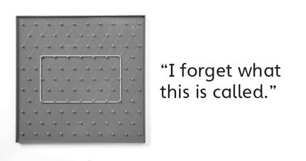 | - Student successfully creates and  identifies shapes and solids from description and visualization.  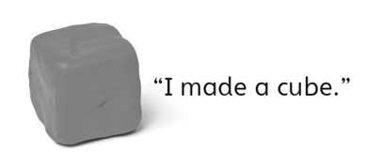
Observations/Documentation

