Building Composite Structures Behaviours/Strategies
- Student plays with 3-D solids, but does not know which solids to use to construct a composite structure. | - Student constructs a composite structure with  3-D solids, but uses only one type of solid or only uses solids with square or rectangular faces.  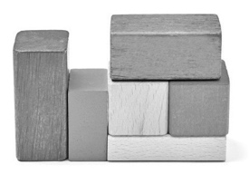 | - Student constructs a composite structure with 3-D solids, but struggles to identify the solids used.  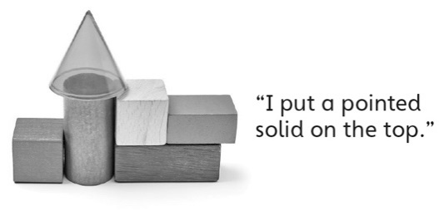
Observations/Documentation
- Student constructs a composite structure with  3-D solids and identifies the solids used, but  struggles to name the shapes of visible faces.  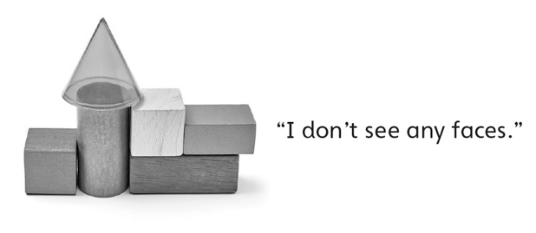 | - Student constructs a composite structure with  3-D solids and identifies solids and faces, but  struggles to compare structures. | - Student successfully constructs a composite  structure with 3-D solids, identifies solids and faces, and compares structures.  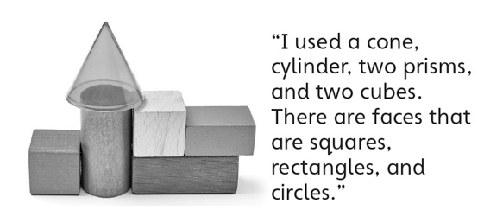
Observations/Documentation

