Our Structure
Master 30a

Stations 1 and 2
We built ____________________________________
Circle the solids you used.
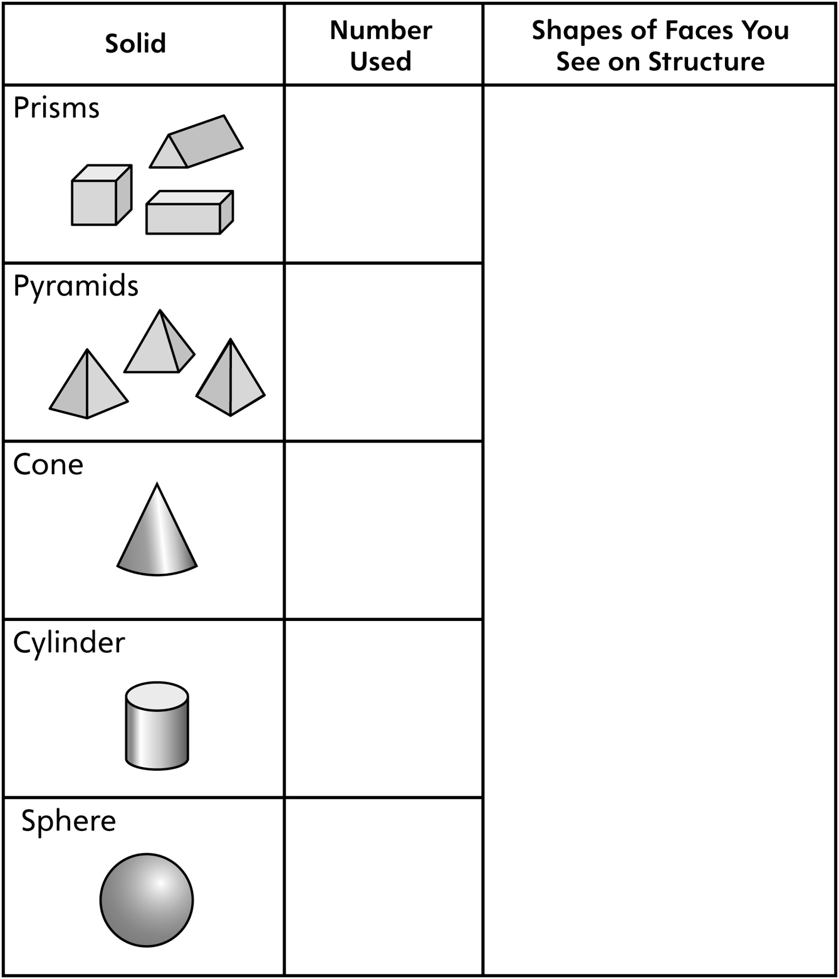
Our Structure
Master 30b

Station 3
We built ____________________________________

