Constructing Skeletons of 3-D Solids Behaviours/Strategies
- Student chooses a solid, but struggles to analyze its geometric attributes. | - Student analyzes geometric attributes of the  solid, but struggles to construct the skeleton  and does not know where to start.  “I don’t know what to do.” | 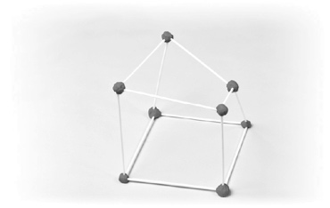  - Student analyzes geometric attributes of the solid, but makes error(s) constructing the skeleton.
Observations/Documentation
- Student analyzes geometric attributes of the  solid and constructs the skeleton, but struggles to determine if partner’s skeleton is correct.  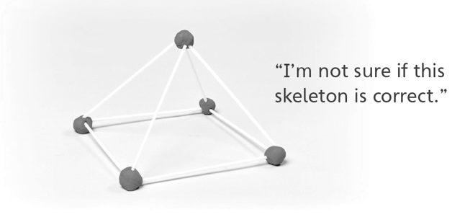 | - Student analyzes geometric attributes of the  solid and constructs the skeleton, but struggles to compare the solid and its skeleton.  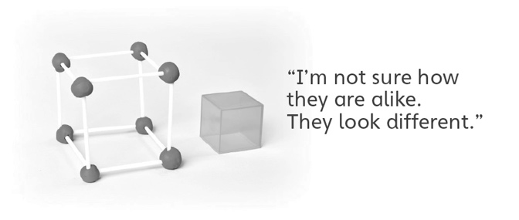 | - Student successfully analyzes geometric  attributes of the solid, constructs the skeleton,  and compares the solid and its skeleton.
Observations/Documentation

