Nets of Rectangular Prisms
(for Combined Grades Extension)
Master 20a

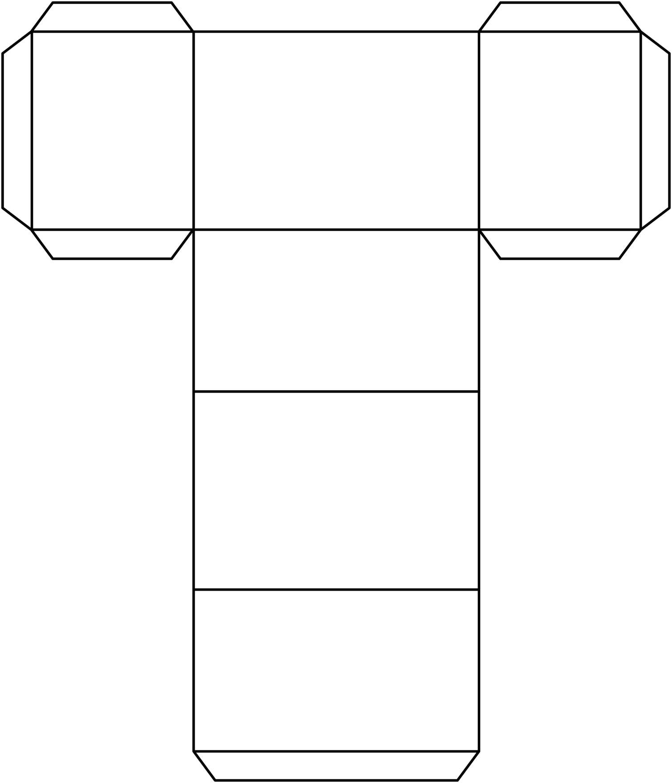
Nets of Rectangular Prisms
(for Combined Grades Extension)
Master 20b

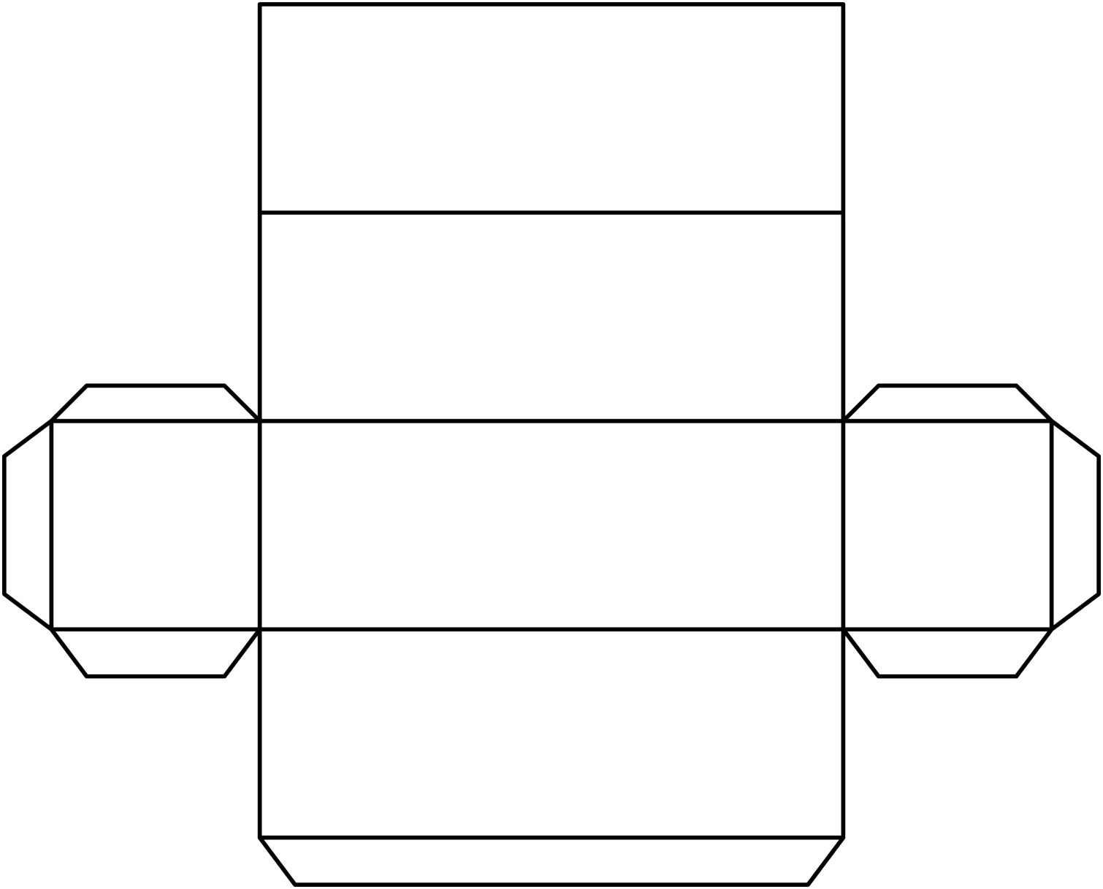

Nets of Rectangular Prisms
(for Combined Grades Extension)
Master 20c

